A level Art and Design- Summer Bridging work 2021

https://www.youtube.com/watch?v=HTw_KqfWtD0
Key words:
Describe
Analyse
Evaluate
Interpret
Summer Challenge: Urban Influences – Mr Lordan

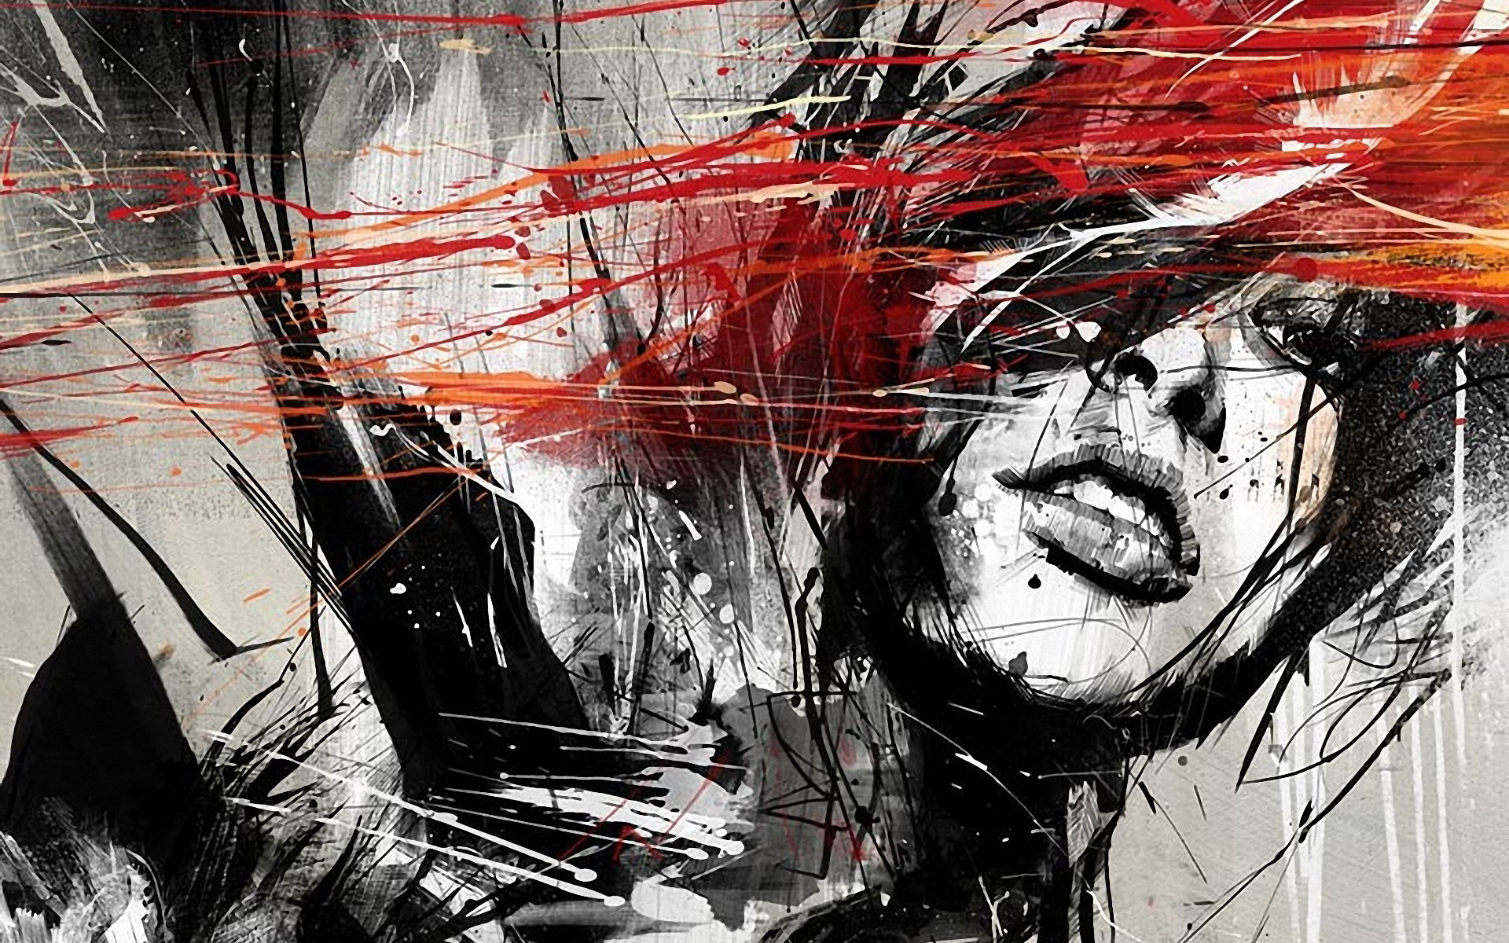
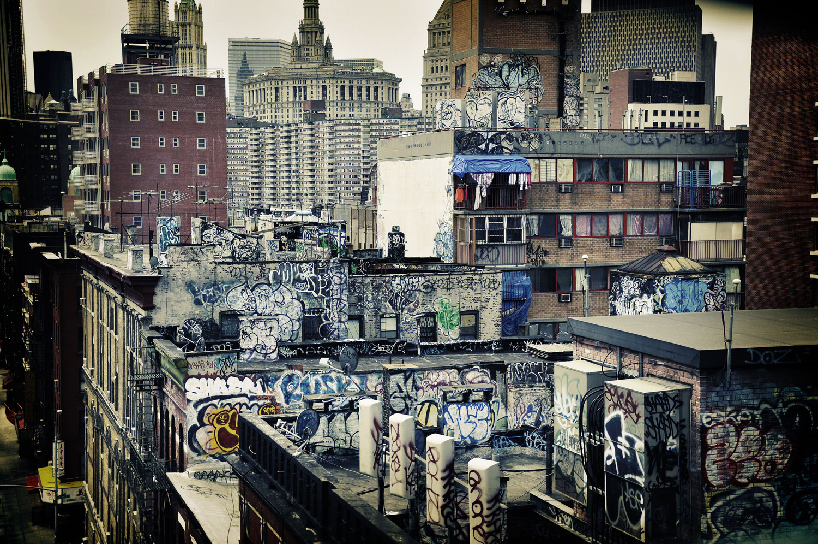
Urban Influences
Over the Summer you will have a chance to start exploring elements of the A level Art and Design course. https://www.aqa.org.uk/subjects/art-and-design/as-and-a-level/art-and-design/specification-at-a-glance
You will study one themed project:
- Urban Influences

Starting your project over the summer….
Urban Influences Tasks (to fill 10 pages)
1. Explore your local environment
2. Take at least 30 photographs of local places that are significant to you and print them
3. Research 4 artworks that show a local environment
4. Make drawings and notes about your local environment and the photos that you took
5. Display your photographs and drawings over at least 10 pages in your sketchbook for your first A level lesson in year 12
6.. Make at least two double page drawings based on your photographs

When visiting your local environment
- Take photographs of your familiar sights you like.
- Record a journey that you take with 10 photographs.
- Take a further 10 photographs looking at the ground a journey that you take.
- Describe your local environment using just 200 words
- Collect 2 local newspapers
- Use your sketchbook as a creative place to try things out
- Describe, analyse, evaluate your work as it progresses.
  - Yr 11 into Yr 12…

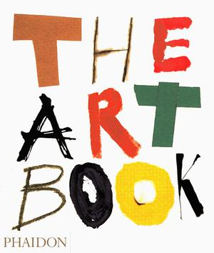
Summer Challenge 2021: Wider Reading (extension Task)
Over the summer holiday you will need to complete Art and Design wider reading.
If you are thinking of applying for an Art and Design related career or degree, wider reading will give you something to discuss in your personal statement or interview.

What do I need to do?
- Pick one book from the list.
- Pick five galleries from the Gallery list .
- Create an A3 spider diagram and mood board explaining what you have learnt from your reading
- The book: What did you learn from it? What quotes were particularly interesting? Why?
- The galleries: What did you think of the gallery/exhibition? (You are allowed to dislike it) What made the exhibition interesting? Do some brief research about the exhibition – explain your understanding of why the exhibition is significant.
Art: What is it good for? (Hodder& Stoughton) ISBN 0-340-84837-5
Ways of Seeing (John Berger) ISBN 0-14-013315-4
The Concise Oxford Dictionary of Art & Artists (Ian Chilvers) ISBN 0-19-282676-X
AS/A Level Art and Design Essential Word Dictionary (Mark White) ISBN 0-86003-382-1
Modern Art & Modernism: A Critical Anthology (Francs Fascine) & (Charles Harris ) ISBN 1-85396-032-2
Movements in Art Since 1945 (issues and concepts) (Thames and Hudson) ISBN 0-500-20282-6
The Shock of the New (Robert Hughes) Thames & Hudson ISBN 0-500-27582-3
The Story of Modern Art (Norbert Lynton) Phaidon ISBN 0-7148-2422-4
The Art Book Phaidon ISBN 0-714829846
Photomontage (Dawn Ades) ISBN 0-500-20208-7
But is it Art? (Cynthia Freeland)
Blimey, and this is Modern Art (Matthew Collings)
The Story of Art (E.H.Gombrich)
Architecture in the Twentieth Century (Goessel Leuthauser) ISBN 3-8228-9056-1
The Ceramic Design Book (larch Books) ISBN 1-57990-176-X
A History of Graphic Design ISBN 0-471-29198-6
The Power of the Poster (Margaret Timmers) ISBN 1-85177-241-3
Graphic Agitation Phaidon ISBN 0714834580
The Power of Photography (Vicky Golaberg) ISBN 1-55859-039-0
The Photo Book Phaidon ISBN 0714876346
Why Not Associates ISBN 1-86154002-7
Typography Now – The Next Wave ISBN 0-89134-621-X
Communicate!: Independent British Graphic Design Since the Sixties ISBN 1-85669-422-4

Reading
List:
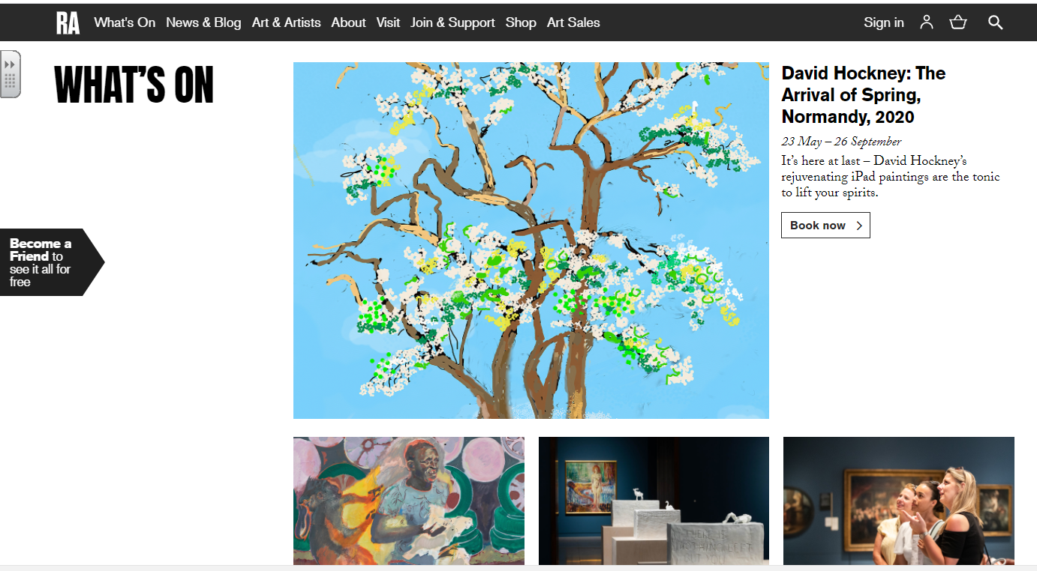
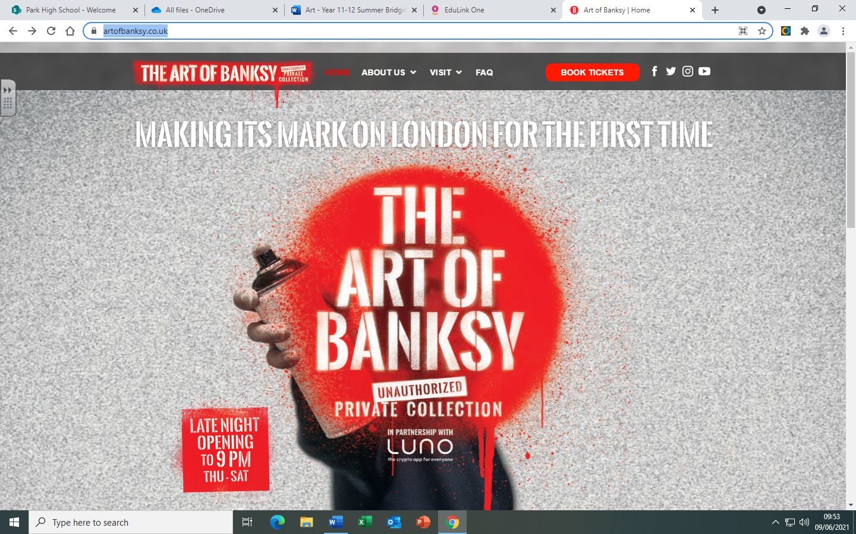
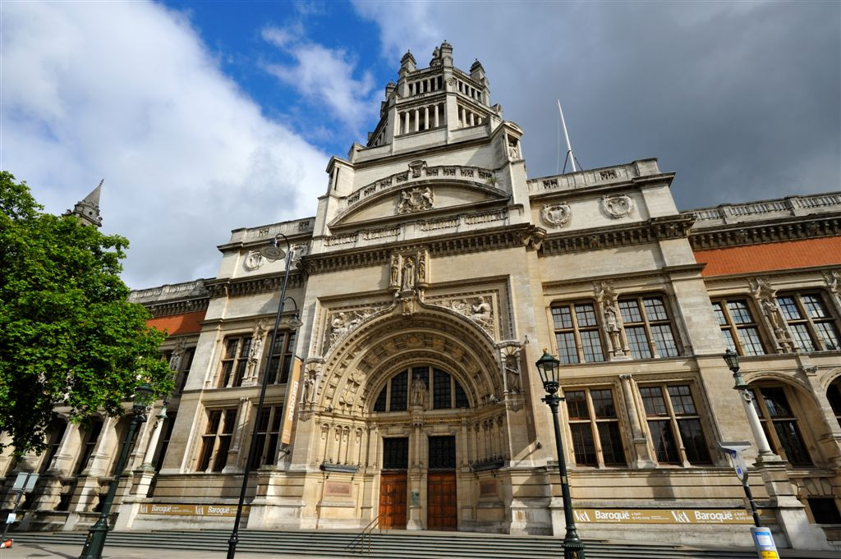
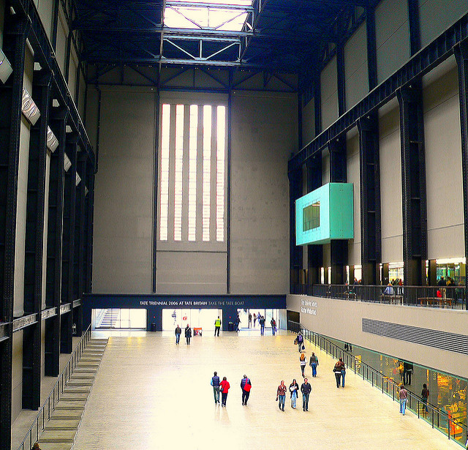
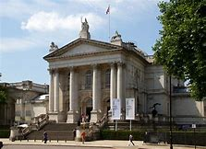
London is the art capital of the UK.
See at least 3 art exhibitions.
Document your visit. Most of it is free.

Current Exhibitions

1. The Royal Academy of Arts. https://www.royalacademy.org.uk/
2. Tate Britain (free) Pimlico tube station. https://www.tate.org.uk/visit/tate-britain
3. Tate Modern (free) Southwark Tube https://www.tate.org.uk/visit/tate-modern
4. Victoria and Albert Museum. High Street Kensington tube (free) https://www.vam.ac.uk/
5. The Art of Banksy https://artofbanksy.co.uk/

Art Galleries Listsd:
Annely Juda Fine Art, W1 - website
Anthony Reynolds Gallery, W1 - website
Barbican Art Gallery, EC2 - website
Brick Lane Gallery, E1 - website
The British Library, NW1 - website
British Museum, WC1 - website
Camden Arts Centre, NW3 - website
Chisenhale Gallery, E3 - website
Courtauld Institute of Art, WC2 - website
Cubitt Gallery, N1 - website
Design Museum, SE1 - website
Dulwich Picture Gallery, SE21 - website
Flowers Gallery Central, W1 - website
Flowers Gallery East, E2 - website
Frith Street Gallery, W1 - website
Getty Images Gallery, W1 - website
Hayward Gallery, SE1 - website
Hoxton Art Gallery, EC2 - website
Imperial War Museum, SE1 - website
Institute of Contemporary Arts - ICA, SW1 - website
Islington Arts Factory, N7 - website
Lisson Gallery 1, NW1 - website
Lisson Gallery 2, NW1 - website
University of the Arts London Gallery, WC1 - website
London Print Studio, W10 - website
National Gallery, WC2 - website
National Portrait Gallery, WC2 - website
Natural History Museum, SW7 - website
Photographers' Gallery, W1 - website
Royal Academy of Arts, W1 - website
Saatchi Gallery, SW3 - website
Serpentine Gallery, W2 - website
Somerset House, WC2 - website
Tate Britain, SW1 - website
Tate Modern, SE1 - website
The Graffiti Life Gallery, E2 - website
UCL Art Museum, WC1 - website
Underground Gallery, WC2 - website
Victoria and Albert Museum, SW7 - website
The Wallace Collection, W1 - website
Wellcome Collection, NW1 - website
White Cube I, N1 - website
White Cube II, SW1 - website
White Cube III, SE1 - website
Whitechapel Gallery, E1 - website

Art galleries

