Bridging Work

Business
Year 11 into 12
Instructions
The following work has been designed to prepare you for your chosen A Level in Business.
All the links have been provided and instructions are included with each activity
Contents
- Research on Aldi
- Comparison research on Waitrose
- Theme 1
- Two tasks
- Wider reading

We look forward to seeing your presentations in September.

Week 1

Inside Aldi: Britain’s Biggest Discount Store Part 1 Channel 5 Documentary
A good business student not only knows their theory, i.e. the content that is on the specification, but also thinks business. Business is a subject that surrounds us all day every day. We start to spot the actions taken by businesses and ask “Why?”; we start to question how we interact with business and the factors that influence our decisions; we start to question what is happening in society and the economy. A good business student is inquisitive.

Start by thinking about what you already know and what your perceptions are. In less than 15 words sum up what you think about Aldi.

Who are the key players in the UK’s supermarket industry?

The pie chart below shows what % of the market the 6 biggest UK supermarket chains control. Use your existing knowledge of the industry to try and identify which segment of the chart represents which supermarket chain. 10% of the chart can just be labelled ‘other’.

Check your answer, Supermarkets.

https://drive.google.com/open?id=1ebzCf6_2Uu7rNbUmBAJ-ayEWMyhHy-Rv

Market share is the % of an industry controlled by one business. In the example above we could say that:
_____________ is the dominant business in the UK supermarket industry with a market share of ____ %. We call this application, applying our knowledge to a specific business or industry.
We would describe the industry as competitive. What do you think this means?
____________________________________________________________________________________________________________________________________________________________________

A business will therefore take actions to try and gain market share by having a competitive advantage. This means a feature or features of the business that allows it to perform better than others in the industry. Watch the first part (approx. 15 mins.) of the Channel 5 documentary “Inside Aldi”.

Draw a spider diagram to show any actions that you think Aldi takes to gain a competitive advantage.

Aldi’s Competitive Advantage

https://www.channel5.com/show/inside-aldi-britains-biggest-budget-supermarket/

Whilst watching this video you were introduced to some key business concepts.
The marketing mix is the combination of elements of marketing that are used to influence customers buying habits. The four Ps of the marketing mix are product, place, price and promotion.
Sometimes the exam board talks about seven Ps, this includes people, physical environment and process. Is there anything you could now add to your spider diagram?
Aldi gains a competitive advantage by charging low prices. It achieves this by making cost savings.
Watch this short YouTube video to learn about total costs.

You may want to download the note taker document here to support you whilst watching this clip.

YouTube https://www.youtube.com/watch?v=CJEkTyj_3Fg&t=5s

Note taker https://drive.google.com/drive/folders/1pnEkyg45xgmBVRWMBTr7BaNsYvWiSNpJ

Is there anything you could now add to your spider diagram?
In business you will learn a lot of new terminology. In this worksheet you have been introduced to 6 key terms.

- Market share
- Competitive advantage
- Marketing mix
- Total costs
- Fixed costs
- Variable costs

You will also be expected to gain confidence in quantitative skills. In this worksheet you have been introduced to quantitative skill (QS) 9: interpret, apply and analyse information in written, graphical and numerical forms.

Week 2

Inside Aldi: Britain’s Biggest Discount Store Part 2 Channel 5 Documentary

In year 1 of Business a lot of the content covered is about tactics. These are short term actions taken by a business. In year 2 you study more about strategy. These are the medium to long term actions taken by a business.

In the first part of the programme you watched, a statement made about the growth of Aldi in the UK was “It is nothing but good for the supermarket industry and for shoppers”. Here the industry would include competitors and suppliers. Shoppers would include customers and the community. These are called stakeholder groups. A stakeholder is anyone who is affected by or interested in the actions of a business. Consider the extent to which you agree with this statement based on each stakeholder’s point of view. Justify your decisions.

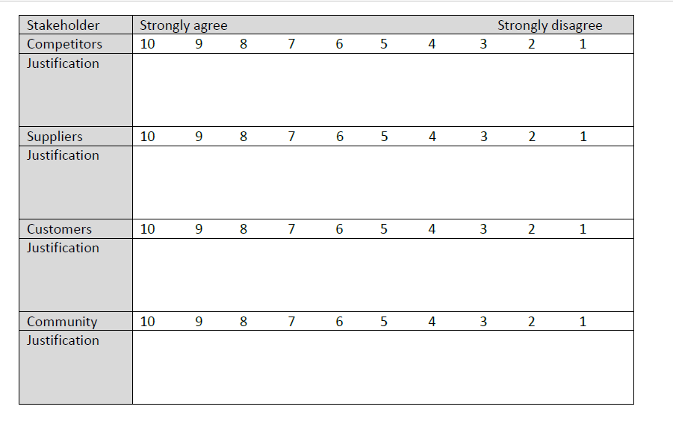

An important skill to practice and develop over your studies is the ability to make judgements and fully justify these. We call this skill evaluation.

Watch the second part (approx. 15 mins.) of the Channel 5 documentary “Inside Aldi”. Add to your spider diagram to show any actions that you think Aldi takes to gain a competitive advantage.

https://www.channel5.com/show/inside-aldi-britains-biggest-budget-supermarket/

What evidence is there of Aldi successfully cutting costs and increasing efficiency?

A topic you will study in year 1 is motivation. Motivation is the reasons why people behave in the manner that they do. A business that can motivate the workforce is likely to gain a competitive advantage. Motivation can take the form of financial incentives e.g. bonuses and non-financial incentives e.g. increased responsibility
What evidence is there of Aldi motivating its workforce?

Business is sometimes a power battle. Big businesses will use their power to influence suppliers. This can be in the form of forcing suppliers to offer lower prices or, in the video you have viewed, forcing suppliers to stop supplying products to a competitor.
Why do big businesses have power?
______________________________________________________________________________________________________________________________________________________________________________________________________________________________________________________

Ethics is behaving in a way that is thought to be morally correct. To what extent do you think the big supermarkets behaved in an ethical manner when faced with the threat of Aldi entering their market?
______________________________________________________________________________________________________________________________________________________________________________________________________________________________________________________

Branding is a promotional method that involves the creation of an identity for the business that distinguishes the business and its products from its competitors. How important is branding to you?

For each of the following products, rate how important brand is to you: 10 being I only ever buy one brand and 1 I will buy any brand. If you have a favourite brand what is it and why?
Product | Importance of brand 10-1 | What and Why?
Baked Beans

Cola Drink

Bottled Water

Trainers

Chewing Gum

Chocolate

Pens

Note Pads

Batteries

Smart Phone

How has Aldi challenged our perception of brands?

In 2013 Aldi had 300 stores in the UK. By 2017 this had increased to 2017 and 874 by 2020. An important quantitative skill in Business is the ability to calculate percentage change. Fill in the table below to show percentage change between these years. If you are unsure how to do this watch the following YouTube clip https://www.youtube.com/watch?v=FOsrkEiZUlg
2013 | 2017 | 2020
300 Stores | 600 Stores | 874 Stores
% Change:

In business you will learn a lot of new terminology. In this worksheet you have been introduced to 6 key terms.

- Tactics
- Strategy
- Stakeholders
- Motivation
- Ethics
- Branding

You will also be expected to gain confidence in quantitative skills. In this worksheet you have been introduced to quantitative skill (QS) 2 calculate, use and understand percentages and percentage change.

You have also had a brief introduction to the 4 functional areas of business.
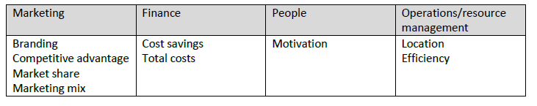

Week 3

Inside Aldi: Britain’s Biggest Discount Store Part 3 Channel 5 Documentary

All business courses cover legal structure or business ownership. This is the legal ownership that a business adopts. This can be unlimited liability businesses such as a sole trader or limited liability companies, be they publicly or privately owned.

Unlimited liability means that the personal assets of the owner(s) are at risk. This means if the business got into debts the owner may have to sell their personal possessions to cover this debt. For example, a sole trader may have to sell their family home and car to cover the debts of the business.
Limited liability means that the owners are only responsible for, and therefore only risk losing, the amount they have invested or promised to invest. Their personal belongings are safe.

Watch the third part (approx. 15 mins.) of the Channel 5 documentary “Inside Aldi”.

https://www.channel5.com/show/inside-aldi-britains-biggest-budget-supermarket/

What is the legal ownership of Aldi?

What are the advantages and disadvantages of this over being a public limited company?
Advantages to Aldi | Disadvantages to Aldi

Businesses are affected by external influences. These are factors outside of the control of the business that can have a positive or negative affect on the business. For example, they may affect costs or demand. Demand is the number of customers who are willing and able to buy goods at a given price at a given point in time.

Watch this short YouTube video to learn about demand. You may want to download the note taker document here to support you whilst watching this clip.

YouTube https://www.youtube.com/watch?v=YuV9RRqahVY&t=107s

Note taker https://drive.google.com/file/d/19L_0RNeJ7ZnE0Jvq8W0CQTtNjk-sHZxF/view

One external factor affecting Aldi was the Financial Crisis.

Was the financial crisis a positive or negative influence for Aldi? Justify your answer.

Can you support your answer above with a demand curve. Think what happened to demand and draw a diagram to illustrate this.

Businesses may target a specific market segment. Market segmentation is the process of categorising customers into groups with similar characteristics. One way of segmenting the market is by income or socio-economic group.

Socio-economic groupings

A – Higher managerial such as chief executives and directors
B – Intermediate managerial such as solicitors, accountants and doctors
C1 – Supervisory, clerical or junior professional such as teachers and junior managers
C2 – Skilled manual such as plumbers, electricians and carpenters
D – Semi and unskilled workers such as refuse collectors and window cleaners
E – Pensioners, casual workers, students and unemployed

What evidence is there of Aldi’s market segment having changed over time?

Consider the other supermarkets competing in this industry. What do you think is the market segment targeted by each one? Remember one supermarket can target multiple segments.
A | B | C1 | C2 | D | E

Recap:

What is the marketing mix?
______________________________________________________________________________________________________________________________________________________________________________________________________________________________________________________
Promotion includes advertising and sponsorship. With reference to Aldi, write your own definition of each of these terms.

Advertising
______________________________________________________________________________________________________________________________________________________________________________________________________________________________________________________
Sponsorship
______________________________________________________________________________________________________________________________________________________________________________________________________________________________________________________

Recap:

What is meant by branding?
______________________________________________________________________________________________________________________________________________________________________________________________________________________________________________________

What evidence is there of Aldi using its branding to gain a competitive advantage?

In business you will learn a lot of new terminology. In this worksheet you have been introduced to 12 key terms.

- Legal structure/business ownership
- Limited liability
- Unlimited liability
- Private limited company
- Public limited company
- Market segmentation
- Socio-economic group
- External influences
- Demand
- Demand curve
- Advertising
- Sponsorship

You will also be expected to gain confidence in quantitative skills. In this worksheet you have been introduced to quantitative skill (QS) 3, construct and interpret a range of standard graphical forms.

Week 4

Inside Aldi: Britain’s Biggest Discount Store Part 4 Channel 5 Documentary

Many established businesses will have an objective of growth. This can be done internally (organically) where the business grows in its own right e.g. opening new stores or expanding its product range. Or it can be done externally (inorganically) by acquiring other businesses.

Watch the fourth part (approx. 15 mins.) of the Channel 5 documentary “Inside Aldi”.
https://www.channel5.com/show/inside-aldi-britains-biggest-budget-supermarket/

Aldi has achieved growth. Write a paragraph to explain how Aldi has achieved growth and what evidence there is of this. Your challenge is to include as many of these terms in your paragraph as you can – show off your knowledge of business!

- Market share
- Competitive industry
- Competitive advantage
- Marketing mix
- Organic growth
- Inorganic growth

________________________________________________________________________________________________________________________________________________________________________________________________________________________________________________________________________________________________________________________________________________________________________________________________________________________________________________________________________________________________________________________________________________________________________________________________________________________________________________________________________________

E-commerce is the selling of goods and services over the internet. Unlike other major supermarkets, Aldi does not offer e-commerce. What are the advantages and disadvantages of this to Aldi?

Advantages | Disadvantages
SWOT analysis looks at the internal strengths and weaknesses and external opportunities and threats to a business. One threat is that of new entrants to the market. Tesco opened Jacks and Amazon has entered the grocery market. Should Aldi be worried. Mark your response on the spectrum below.

Seriously worried
Not a problem

Justify your answer:
____________________________________________________________________________________________________________________________________________________________________________________________________________________________________________________________________________________________________________________________________________________________________________________________________________________________________________________________________________________________________________

Corporate social responsibility (CSR) is a business’ willingness to accept its ethical obligations to all of its stakeholders.

The ability to carry out independent research and read around your subject are important skills in all subjects in the sixth form and beyond.

Carry out some research into the Oxfam study https://www.oxfam.org/en/take-action/campaigns/end-suffering-behind-your-food/supermarkets-scorecard

Look at Aldi’s commitments to corporate responsibility https://www.aldi.co.uk/corporate-responsibility
How would you rate Aldi’s CSR?
Justify your answer.

In this worksheet we have looked at some key year 2 concepts as well as year 1.

Consolidate all of your notes into a SWOT analysis for Aldi. You could produce this on the computer.
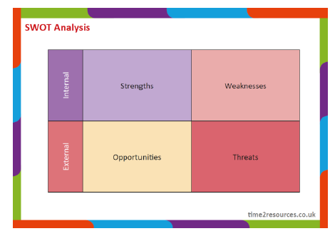
In business, you will learn a lot of new terminology. In this worksheet you have been introduced to 7 key terms.

- Objective
- Growth
- Internal (organic) growth
- External (inorganic) growth
- E-commerce
- SWOT analysis
- Corporate social responsibility

Week 5 and 6

Another Channel 5 documentary is “Inside Waitrose”. You should watch this to complete a comparative study looking at the similarities and disadvantages.

https://www.channel5.com/show/inside-waitrose/

Week 7 and 8

Theme 1
Syllabus area
Introduction – what is a market?
1.1.1 The market
Mass markets and niche markets
Dynamic markets
1.1.2 Market research
Product and market orientation
Methods of market research
Uses and limitations of these methods
Market segmentation from market research results
1.1.3 Market positioning
How businesses use market research information

Activities
Task 1 – research a range of business examples, such as local tradesmen or national businesses such as Greggs, Tesco, Next, ASOS, Debenhams, Game, HMV, Misguided and identify their markets.
Task 2 - You need to describe market size and market share – combine this with research on recent news regarding the business’s approach to branding.
One useful source of information on markets is www.keynote.com. Newspaper websites could also be used.
Interesting case studies could include:
ASOS - https://businesscasestudies.co.uk/strategic-growth-in-the-fashion-retail-industry#axzz2zv5KAbrb
Kelloggs - https://businesscasestudies.co.uk/using-new-product-development-to-grow-a-brand/
Body shop - https://businesscasestudies.co.uk/the-body-shop-approach-to-stakeholder-auditing/
Task 3 - You should carry out your own surveys using both open and closed questions to enable you to gather quantitative and qualitative information to determine likely demand for new menus in the school canteen, for school business enterprises or for fund raising/charity events.
Government websites are useful secondary sources:
- www.statistics.gov.uk/hub/index.html
- www.statisticsauthority.gov.uk/
Task 4 – Research and compare the ice cream brands Wall’s, Nestlé and Häagen-Dazs and consider how and why they differentiate their products

Assessment - 1

- You need to produce a PowerPoint ready to present on your return in September and in the first lesson.
- Your presentation needs to be 5 minutes maximum
- Produce a hand-out A4 single side to submit with your research alongside your findings

Week 9 onwards

Activity
Select ONE book from the list below (some of these can be bought used from Amazon for 1p). The highlighted ones are easier to read.
BUSINESS STUDIES READING LIST
100 greatest ideas for effective leadership and management | John Adair
Anyone Can Do It: My Story | Duncan Bannatyne
Competing for the Future | Gary Hamel/C Prahalad
Competitive Strategy: Techniques for Analyzing industries and Competitors | Michael E. Porter
Don’t Work and What to Do about It
Shoe Dog (Nike) | Phil Knight
Freakonomics: A Rogue Economist Explores the Hidden Side of Everything | Steven Levitt/S Dubner
Ali Baba – The house that Jack Ma built | Duncan Clark
Good to Great: Why Some Companies Make the Leap…and Others Don’t | Jim Collins
Elon Musk: How the Billionaire CEO of SpaceX and Tesla is Shaping our Future | Ashlee Vance
Losing My Virginity | Richard Branson
No Logo | Naomi Klein
Organizational Culture and Leadership | Edgar H. Stein
Out of the Crisis | W. Edwards Deming
The Everything Store – Jeff Bezos and the age of Amazon | Brad Stone
Tescopoly: How One Shop Came Out on Top and Why It Matters | Andrew Simms
The Bottom Billion: Why the Poorest Countries Are Failing | Paul Collier
The E-Myth Revisited: Why Most Small Businesses Fail | Michael E. Gerber
Steve Jobs: The exclusive biography | Walter Isaacson
The Long Tail: How Endless Choice Is Creating Unlimited Demand | Chris Anderson
The Practice of Management | Peter F. Drucker
How to turn down a billion dollars – The Snapchat Story | Billy Gallagher
The Real Deal | James Caan
The Snowball: Warren Buffett and the Business of Life | Alice Schroeder
The Tipping Point: How Little Things Can Make a Big Difference | Malcolm Gladwell
The Wisdom of Crowds: Why the Many Are Smarter Than the Few and | James Surowieki
The Airbnb Story: How to Disrupt an Industry, Make Billions of Dollars … and Plenty of Enemies | Leigh Gallagher
Tycoon | Peter Jones
Who Runs Britain? How the Super-Rich are changing our Lives | Robert Preston
Wikinomics | Don Tapscott
World at your feet | Sabirul Islam
The ride of a lifetime (The story of Disney) | Robert Iger

Assessment 2
Write a book review (use PPT) on the book that you have read. Highlight:
What the book was about?
What was interesting?
What did you learn?
Would you recommend this book?
How many stars would you give it out of 5.
Your presentation should be no longer than 5 minutes.



