Preparing for Post 16 Drama and Theatre Studies

Dear 11 Students,

During these ever changing and difficult times it is very hard for you all to feel like you know how best to think about your education. With the picture over exam grades yet to be clearly defined at this point it feels better for you all to think about your next steps instead and look to work on preparing for post 16 courses. Most of you will have a good idea about what you intend to study next year and therefore subject leaders for all of the A-Levels we teach at Park High have devised some preparation work that you can work on during the next few weeks.

Drama and Theatre Studies
In year 12 you will study a range topics which feature in the Drama and Theatre Studies A Level. These include a study and application of different theatrical techniques, practitioners, plays and self-reflection.

Why this work?
Before starting the course it is really useful to have some awareness of the differences between Drama and Theatre and understand the holistic practice of each area. It is also useful for you to begin your learning journey in the subject by experiencing as much performance as possible. You might find that people are using vocabulary that you have never heard and also ideas that you’ve never come across. Don’t worry - remember we will go through all of this when we teach you! We just want you to begin to develop some knowledge and understanding in these areas.

Where should I complete it?
Please complete any notes either on paper or on your computer and save them to bring into school at a later date.

How long will it take?
The work has been divided into weekly tasks. Each week of tasks should take between 1-2 hours.

Week 1 – 21st June 2021
Set Text
Task 1
Read the play ‘That Face’ by Polly Stenham, making notes within your script –
- Underline or highlight words or sections you do not understand.
- Write your own notes next to sections of text based on your own understanding of the dialogue.
- Identify key theatrical and design moments throughout the play and note these on your script.

Task 2
Create a fact sheet based upon the play ‘That Face’ and its playwright Polly Stenham. This should include:
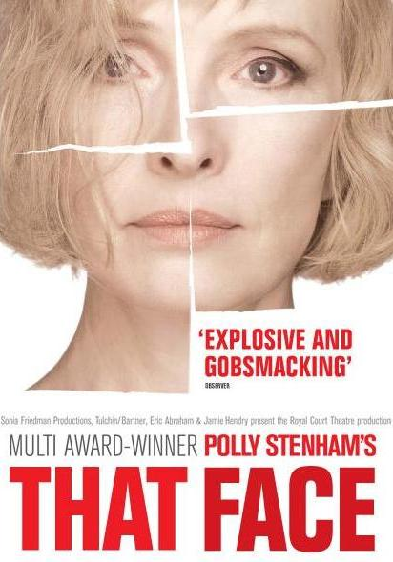
- Biographical information about the playwright
  - General biographical info
  - How did they become a playwright?
  - What key people did they work with as they were developing?
  - What is their style of writing?
  - What other works have they written? Where have they been performed?
  - Have they won/been nominated for any major awards?
- Key information about the play
  - Themes
  - Basic summary of plot
  - Characters

Week 2 – 28th June 2021
Theatre Roles
Watch the following videos and write a paragraph regarding each job role in the theatre:
- Sound Designer
- Set Designer
- Costume Designer

Costume Playlist
https://www.youtube.com/watch?v=widLgDuK-nk&list=PL38C3370FBD126CA8
Set Videos
https://www.youtube.com/watch?v=UVTRWx8_CKA&t=99s
https://www.youtube.com/watch?v=Tv_geitX9_4&t=15s
https://www.youtube.com/watch?v=K1eFxlcwRI8
Sound Designers
https://www.youtube.com/watch?v=MGtX9P8gDI8

Week 3 – 5th July 2021
Live Theatre Performance
Watch a live theatre performance and write your own article based on the production you have seen.
Select a performance from Digital Theatre Plus (please note the new website and log in).
https://edu.digitaltheatreplus.com
Login
Username: drama_140
Password: CHScreativearts1
1000 Word Live Theatre Evaluation
For your review, you need to comment on the following:
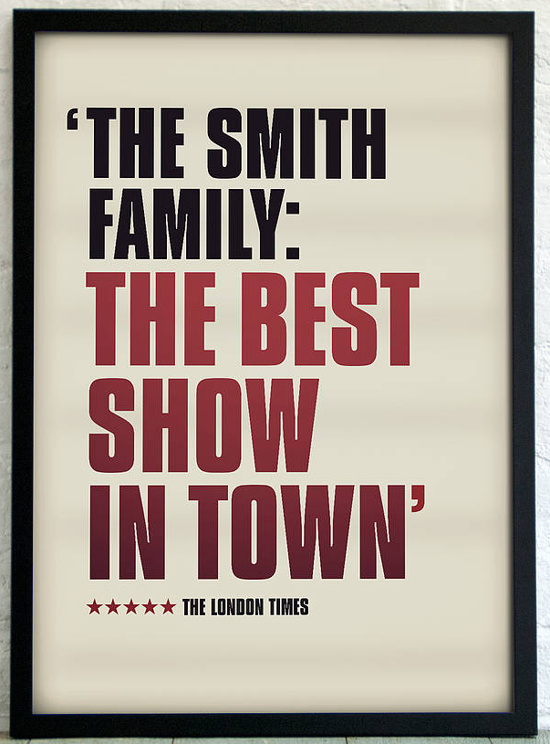
- Title of work and where/when it was performed.
- Identify key people involved in the production e.g. the director, lighting designer, accompaniment designer etc. Buying a programme should assist with this.
- Choreographic Style of the work.
- The constituent features of the work and WHY they were effective:
  - Costume
  - Lighting
  - Sound/music
  - Style – can you link to any practitioners?
  - Set Design
- Your experience as an audience member. What was the impact on the audience? Was the piece successful?

NB: reading real reviews of plays online is really useful to assist you in gaining a professional sound to your review. Try to avoid using ‘I’ and be subjective with your views of the work. Here is an example review to assist your writing.

Review Example 1
Play: Shakespeare’s Richard III
The Diorama Theatre supplies a range of theatre to London. The Faction often perform here and are well known for their abstract performances. Their interpretation of Richard III was a skilful and interesting physical piece which retained the key themes of the original Shakespearian play – corruption, manipulation and evil whilst associating with modern politics.
The cast of The Faction were to be able to engage their audience through their performance and skilful imagery. Richard, played by Christopher York, was a captivating member of the cast portraying Richard as a twisted hunchback, with barefoot crossed toes and a flickering hand. This physicality seemed like a manifestation of Richard’s evil. However, the hunchback wasn’t always physically displayed, and it only appeared when things weren’t going accordingly to him. The hunch retreated back when his plans were heading in the right direction. This technique was cleverly used to show when he was at his weakest or his strongest. One particular scene which supports this view is when Edward V and Richard were play fighting and he had jumped onto Richards back. In doing so the disfigurement was caused again, showing that he was in a weak position, manipulating those around him to perceive him as weak.
Clarence's death was the most cleverly captivating scene. This scene was serious as well as comedic and the director, Mark Leipacher, used the two executioners as a metaphor for the two protagonists from the film ‘Dumb and Dumber’ directed by Peter and Bobby Farrelly. The scene was set in Clarence’s chambers with no props; however the movement and certain actor’s gestures helped the audience differentiate from the corridor and Clarence's chambers. This was well executed through their limited us of space and consistent bumping into each other. The humour, kept me on the edge as it helped to build tension and foreshadow death. When the two executors entered Clarence’s bedroom they entered through a rather large door. I could infer this from the sound effects and the executioner’s gestures. This was well-executed, although the sound itself did seem a little weak and the director could have further utilised his large cast to create a more visual portrayal . Upon their entrance to the jail cell, the lighting subtly changed to a royal blue, which successfully exposed Clarence's fear and foreshadowed his death of drowning. As the second agent slowly approached Clarence from behind, the lighting changed again to a bloodshot red to imply that Clarence had been stabbed in the back. He was then dragged across into the corner of his chamber near a barrel. The other executioner had grabbed Clarence's head positioning it in order to drown him into the barrel filled with water. A gurgling sound was used to reflect the moment. This empty warble didn’t truly mirror the terror of the moment, and was a weak way to demonstrate the characters death.
The Faction also used many aspects of physical theatre. A scene, which represents this well, is when Richard takes to his throne. People who he previously murdered physically constructed the throne. This shows that whatever crimes he committed, they all contribute to his attainment of the crown. They quite literally represented the people he had stamped on en route to power. The hierarchy amplified Shakespeare’s original portrayal of Richard III as a Machiavellian villain. When the executioners were lifting Christopher York, the men were crouching with their heads facing the floor whilst the lighting was corresponding- a dark tinted black that allowed the audience to faintly see the starting of his rise. As Richard started to arise, the lighting became more vibrant in colour- to a rose gold. I felt this signified the vicious actions he had done in order to get to the royal seat. Firstly killing everyone in his path to attain this name, then using these same people he murdered to symbolise his throne. This is a wicked metaphor meaning that those who were killed by Richard’s hands helped him rising position in the kingdom. The dark lighting at the beginning of the scene could have portrayed the evil plans conjured by Richard in order to gain his place on the throne. On the other hand, the rose gold lighting may have symbolized his prized thoughts even after forgetting about the brutality of his acts.
I felt the close proximity of the stage to audience was well used towards the end of the performance. Those who were wronged or killed by Richard stood on the steps beside the audience’s seats as if they were witnessing his death for amusement or pure revenge. I felt that this had an impact on the audience's emotion towards Richard, he was deliberately portrayed to be hated and so he was. The fact that those killed or wronged were on the audience's side also watching his death as if it were their entertainment, also made me feel as if we were all in abomination against him. All on one team. The climax towards Richard’s death was extremely nerve racking to watch as he was placed right in the centre of the battlefield dodging the arrows, along with the whole-cast physical portrayal of the battle. As the battle continued the background music got louder and faster as if in anticipation of Richard’s death. Along with the speed of the music, the characters on the stage had quickened the dynamic of their movements. This could have been a representation of Richard’s fast heart beating due to the fright and worry as he may have known that his death was approaching. However, once the arrow had struck him, all the havoc had slowed down. Therefore time was caught upon him in order for him to receive the pain he deserved, slowly but surely.
The Faction’s interpretation was a successful visual, one which drew the audience into a world which they face every day – that of power-hungry leaders and backstabbing politicians. I felt that this was the message they were trying to communicate, that Richard’s manipulative techniques are still used today.

Week 4 – 12th July 2021
Practitioner Research – Task 1
Watch the following videos based on the three practitioners we study at A Level:
Brecht
https://www.youtube.com/watch?v=l-828KqtTkA
https://www.youtube.com/watch?v=c7fqMPDcKXM
There are also videos based on Brecht on Digital Theatre Plus.
Artaud
https://www.youtube.com/watch?v=DK_vZuLYHcw
https://www.youtube.com/watch?v=hpfVW6otfyQ
Frantic Assembly
https://www.youtube.com/watch?v=nVs_-Rq3BT0
https://www.youtube.com/watch?v=pAUxkH3q_HQ
There are also videos based on Frantic Assembly on Digital Theatre Plus.
Practitioner Research – Task 2
Create your own table and summarise what you have learnt about each practitioner.
What I have learnt about:
Brecht | Artaud | Frantic Assembly
1 | 1 | 1
2 | 2 | 2
3 | 3 | 3
4 | 4 | 4
5 | 5 | 5
6 | 6 | 6
7 | 7 | 7
8 | 8 | 8
9 | 9 | 9
10 | 10 | 10

Week 5 – 19th July 2021
Set Text – Task 1
Read the play ‘Woyzeck’ by George Buchner making notes within your script –
- Underline or highlight words or sections you do not understand.
- Write your own notes next to sections of text based on your own understanding of the dialogue.
- Identify key theatrical and design moments throughout the play and note these on your script.

Set Text – Task 2
Create a fact sheet based upon the play ‘Woyzeck’ and its playwright George Buchner. This should include:
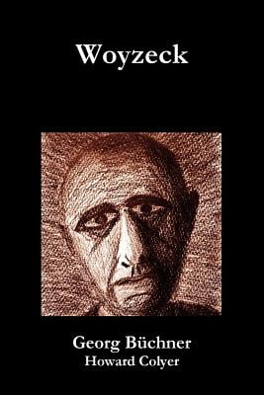
- Biographical information about the playwright
  - General biographical info
  - How did they become a playwright?
  - What key people did they work with as they were developing?
  - What is their style of writing?
  - What other works have they written? Where have they been performed?
  - Have they won/been nominated for any major awards?
- Key information about the play
  - Themes
  - Basic summary of plot
  - Characters

