Year 12 Economics Bridging work

Mrs Pindoria
Park High School

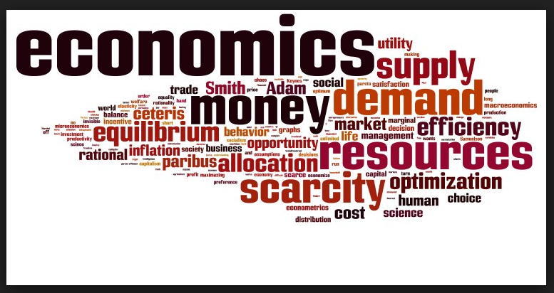

Over the next few weeks you will be investigating "what is Economics?" and will be introduced to key economic concepts, as well as introducing some key macro-economic events from the past.

You need to work through the tasks below and bring in all of your work ready to hand in to your teacher in September:

Week 1 – What is Economics?
- To start with, we would like you to watch the following videos:
Crash Course Economics “What is Economics?” https://www.youtube.com/watch?v=3ez10ADR_gM&t=130s (12 minutes)
Ha-Joon Chang https://www.youtube.com/watch?v=NdbbcO35arw (12 minutes) Economics is for Everyone
- Then visit the BBC Economic news page www.bbc.co.uk/news/business/economy. Read two of the stories you find here. Start making a list of economic terminology and find out the economic meanings of any terms you are unsure of.
- Now write a 400 word essay explaining why you have chosen this subject.

Week 2 – Microeconomics/Macroeconomics
- Watch the Tutor2u video below: Introduction to Microeconomics and Macroeconomics". www.youtube.com/watch?v=2Nq8LN3XGQA&feature=emb_rel_pause
- Explain the difference between microeconomics and macroeconomics.

Week 3 – HS2- Northern Powerhouse
Updates on the HS2 have been in the news recently.
“The transport secretary has said that the HS2 high speed rail network's eastern leg, linking Birmingham to Leeds, will go ahead and could even be delivered earlier than planned, the transport secretary has said.
The HS2 network is due to be built in stages, with the final leg to Leeds completed by 2040.”
https://www.bbc.co.uk/news/business-57282010
https://www.hs2.org.uk/
https://www.theguardian.com/uk-news/2021/jun/08/london-council-residents-hs2-construction-construction-high-speed-rail-project
Task- Using the links above, answer the following questions. (you may also decide to find your own sources)
- Identify who the possible “winners” and “losers” of the HS2 might be.
- For each of these groups of winners/losers, now explain why they may benefit or be harmed by the development of HS2.

Week 4 – The Global Financial Crisis 2007/8
- Follow the link below to an excellent BBC report on the fallout of the 2008 Global Financial Crisis. Read this report.
www.bbc.co.uk/news/resources/idt-sh/The_lost_decade
- Watch the Crash Course Economics video on the 2008 Financial Crisis
www.youtube.com/watch?v=GPOv72Awo68
- Summarise the main causes of the global financial recession of 2008 and explain a few of the implications it had on the UK economy. (400 words)

Week 5- Movie
It's movie time......Choose one of the following to watch. Your choice may depend on what you are able to access:
- The Wolf of Wall Street
- The Big Short
- Money Explained (Netflix only)
- Too Big to Fail
- A Beautiful Mind
- Inside Job
…… Get some popcorn and enjoy!


Before you arrive to Economics in September, as well as completing the tasks, you will also need to make sure you have done the following:


- Print off the specification (7136) and familiarise yourself with the topics for each unit. (Pages 28-56 4 A level content) You will find the spec on the link below.
http://www.aqa.org.uk/subjects/economics/as-and-a-level/economics-7135-7136

- Buy a folder and some dividers (pack of ten)
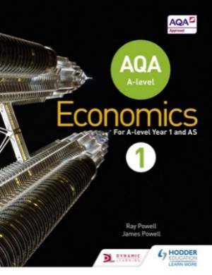
3) Make sure you have the textbook for September.

AQA A-level Economics Book 1
UK ed. by Ray Powell, James Powell (ISBN: 9781471829789)

