History A Level: Y11 to Y12 Bridging Assignment

Aims of this work:

- To develop your interest in the topics being studied in Y12
- To provide a basic foundation knowledge and understanding of the wider historical contexts for the periods of study – i.e. what was going on around that time
- To develop your skills of independent study

What are the topics?

Unit 1 –  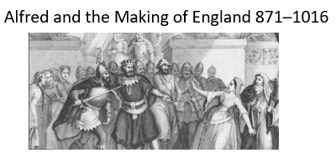 | Delivered by Mr Frankcom
 | 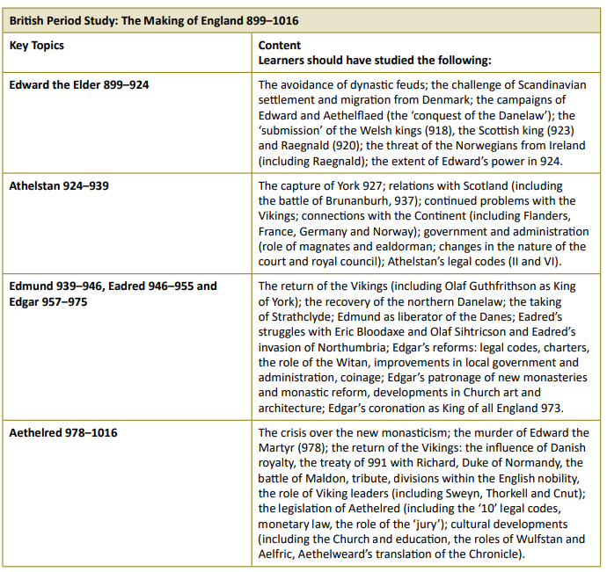
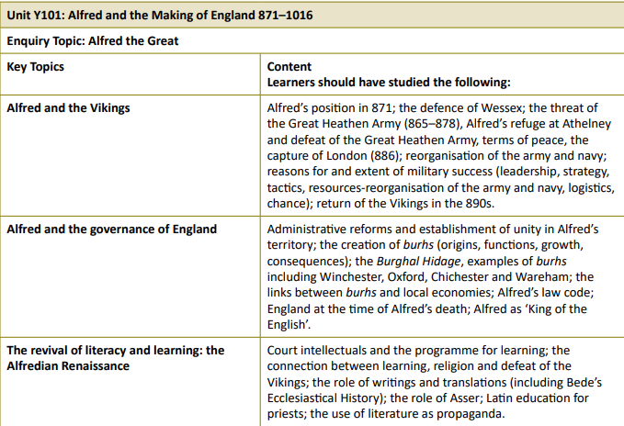

Unit 2 – Russia 1894-1941 | 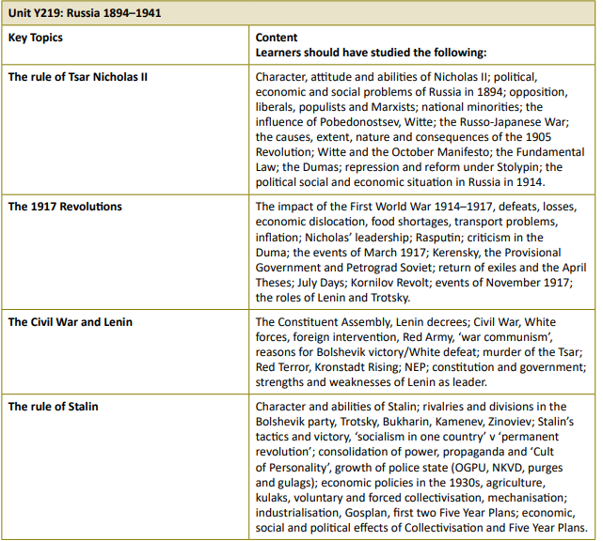
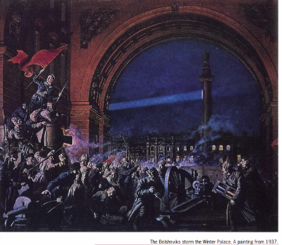
Delivered by Mr Kenward

** Please note that this topic replaces the previous planned topic on France 1814-70 due to a lack of available resources **

Tasks to do: You have tasks to do for each unit. You will be expected to produce 2 pieces of work at the end of this project, one for each unit. Hand this in during your first lesson in September and be prepared to discuss your learning. Each task should take a maximum of one hour.

Week beg. | Tasks for unit 1 | Tasks for unit 2
Week 1 | Watch this video about Saint Augustine of Canterbury and write a narrative account of his life. You could write it in the style of someone who admires him enormously.  https://www.youtube.com/watch?v=ztIOY9J85vI | Watch this video about the origins of Russia. Then watch it again, pausing when necessary, so that you can write a list of 10 facts which comprehensively summarise the main points.  https://www.youtube.com/watch?v=lfe1wEQzSzM
Week 2 | Find maps of Britain in the period between 700AD and 800AD and make a short country profile for each of the following kingdoms:  - Northumbria  - Mercia  - East Anglia  - Wessex  Your profile should include the sort of geographical information a tourist of the time might find useful or interesting to know. | Watch this video about the entire history of Russia in terms of its political borders and write 5 conclusions/observations and 5 questions it raises in your mind. Do some research to find some basic answers to your questions: https://www.youtube.com/watch?v=31oU-LwvyqY
Week 3 | Watch this short video featuring the farmer Bealdric and outline any similarities and differences with the way he speaks and modern English.  https://www.youtube.com/watch?v=oFX1nbD3dV0  After you have done that print out this map and write in the name of the shires (counties) of England in the appropriate places.  https://commons.wikimedia.org/wiki/File:England_and_Wales_Historic_Counties_HCT_map.svg | Do some research into the Tsars of Russia, from first to last.  - Define the term ‘Tsar’ (alternate spelling is ‘Czar’)  - Create a timeline of all Tsars/ Emperors  - Identify those who are the most well-known and state the reasons for their historical fame (i.e. what were their main achievements?)
Week 4 | Watch this video and (a) outline what the different characters think about Alfred of Wessex, and (b) what things do you think interest and motivate Alfred?  https://www.youtube.com/watch?v=yJ0puT8mMGA | Watch this BBC documentary - you do not have to make notes, but focus on what is said about challenges facing the Tsars in the 19th century:  https://www.youtube.com/watch?v=3TIRaGMOxGo
Week 5 | Watch this video and make notes about the Vikings; where they came from; where and how they travelled; what sort of things did they believe in and motivated them?  https://www.youtube.com/watch?v=9HdUtpKBDUc | Watch this video about Karl Marx’s philosophy and write your own thoughts in response to it – approximately one page of bullet points or a maximum of 2 sides of writing: https://www.youtube.com/watch?v=gR3igiwaeyc
Week 6 | Undertake some research in order to create a “Timeline of Late Anglo-Saxon History” covering the period 700AD to 1000AD. Your timeline should have ten events for each century (30 in total) which you think are most significant. | Watch this short video and identify all the key words in it. Then research the meanings of those words and write yourself a glossary.  https://www.youtube.com/watch?v=FrtDZ-LOXFw
Week 7 | Answer this question in no more than 750 words, using your notes from the above tasks: What are the main features of society and politics in the Late Anglo-Saxon Era? | Answer these 2 questions in no more than 500 words each, using your notes from the above tasks: (a) What are the key elements of Russian history before 1900? (b) What is communism?

