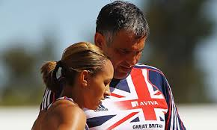
- Relationship between intrinsic and extrinsic:
- Question: 4 marks
Motivation:



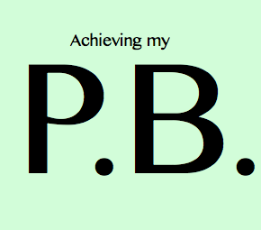





You are more likely to succeed if you have…
MOTIVATION
What DRIVES us to succeed?
Extrinsic Motivation

Intrinsic Motivation

Motivation can influence your:
- Selection and preference for an activity
- Persistence
- Effort levels
- Performance levels relative to your ability level.

