2021 - Year 11 into 12 bridging work – D&T
AQA Design and Technology
Bridging work information and requirements.

Before you arrive to A level D&T in September, you need to complete the following tasks…
- Read the specification – see what key points you already covered on your GCSE course, and how the A level will extend your understand further in to industry and the real world of design.
https://www.aqa.org.uk/subjects/design-and-technology/as-and-a-level/design-and-technology-product-design-7552
- Buy a folder and dividers (pack of ten), The first lesson we will put the specification as the first section in your folder.
Where should I complete the bridging work for D&T?
Present the work below on paper with your name clearly on each page, ready to hand in the first lesson in year 12. The quality and depth of work you hand in on the first lesson will indicate if you will be staying on the course. Remember this is a design course so presentation and creativity on your pages must be shown.
How long will it take?
The work has been divided into weekly tasks. Each week of tasks should take between 2-3 hours.
Below you will find tasks to work on each week, keep all this work and bring it to your first D&T A Level lesson.
Week 1
After reading the specification write on lined paper, our you can type and print this - write what your thoughts are about the course,
1.What are your expectations of the course?
2.How is it different to your GCSE course?
3.Are there any surprises?
4.What might be a challenge? How might you overcome these challenges?
5.How might your studying habits need to evolve to be successful is passing this course?
6.What are your thoughts on the Maths and Science content of tis specification?
7.What skills will you build on?
8.What do you understand about the NEA? How is it different from your GCSE course?

Week 2
To build your knowledge of production processes you need to research the following and give advantages and disadvantages of each:
1. Injection moulding
2. Die casting aluminium
3. Just in time manufacturing
4. Lean manufacturing
You might want to present this work as a table, or as 4 separate sheets of research. Include example products and where each type of manufacturing might be used in industry.

Week 3
Research and produce a write up, with a step by step of processes for each of the following different forming methods, name specific products and scales of production (one off, batch, mass etc)
• vacuum forming
• injection moulding
• blow moulding
• rotational moulding
• extrusion
• compression moulding.
• thermoforming
• calendaring
• line bending
• laminating (layup)

Week 4
Develop your knowledge of designing and developing your designs you need to research what and ‘Iterative’ approach to designing means.
Then you need to:
1. Design 2 solutions for a hand held product to pick up plastic bottles from the floor
2. Pick your best idea and provide 2 developed iterations of your product. (you could add photographs of models if you want to model at home, or use CAD to develop ideas)
For each of the above you need to annotate your designs for materials, components and ergonomics.
State how ergonomics and anthropometrics are considered in your design work.

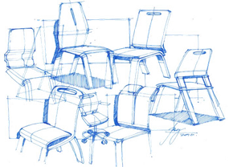
Week 5
The image on the right shows sketches for a chair. You can see that there are nice sketchy lines and some ‘crating’ to achieve the form. Also shading to help make the product look realistic.
Sketch a piece of furniture from your home- it must be 3D and show some construction detail.
Explain the main features of the product. You need to include notes about:
- Materials and why they have been selected.
- Ergonomics – (how the product is comfortable and easy to use.)
- Overall sizes using dimensions to show the important information.

Week 6
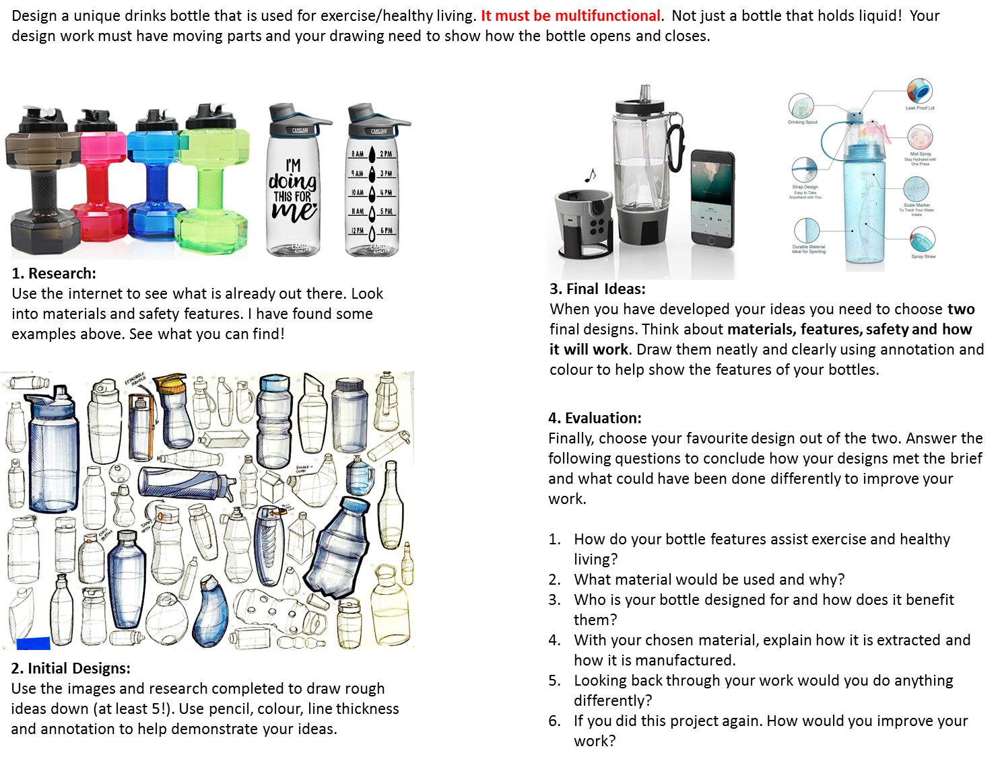

Week 7
Wider Reading (Books, articles, podcasts and videos)
Below is a list of links to relevant websites, articles, videos and shows.
These are here purely to extend your knowledge of current trends in design and how it is currently being used in the world today.
Evidence any wider reading you do by summarising what you have learned. (potentially through bullet points, a review, a small paragraph, a reflective piece of writing or any other media you find appropriate such as trying out some of the drawing techniques)

- https://99percentinvisible.org/?fbclid=IwAR3-foomjkomcOnvRDw79upF5BnrVkY9W5cuU2ix82ntkjuYOL6qEsJ4L84 – A long series of podcasts about products and other ways in which design has impacted the world
- https://www.bbc.co.uk/programmes/b08k9pv0?fbclid=IwAR1O-REp7H72oZnoEemZZ6Bby7mXouo019xIfZR1wuENSAAoFKI--NPhqXo – Podcast about ideas and inventions that created the modern world.
- https://www.dezeen.com/design/ - podcasts, articles, design newsletters and magazine.
- https://www.bbc.co.uk/programmes/m000gwzg How to Make series starts beginning of April on BBC Four
- https://www.bbc.co.uk/iplayer/episode/m0007trf/bauhaus-100 Bauhaus 100
- https://www.bbc.co.uk/programmes/b05ttnd7 Handmade craft
- https://www.bbc.co.uk/programmes/b09rfb1v Inside story of IKEA
- https://www.youtube.com/channel/UCELt4nocnWDEnYJmov4zqyA – How Its Made YouTube. Loads of content on production processes and materials uses.
- https://www.youtube.com/watch?v=9uOMectkCCs – The Secret of Great Design – TED Talk
- https://www.youtube.com/channel/UC62Ngsd_ZBWkX-6yFV-10UQ – Product designer maker youtube channel
- https://www.youtube.com/channel/UCxyQKi7ipjA3Cz-VQUYanNQ – Producttank youtube channel
- https://www.youtube.com/watch?v=FwvLkmdV9QA – Interview with Braun
- https://www.youtube.com/watch?v=wChkvofR7Q0 – Dieter Rams’ 10 Principles of Good Design
- https://www.youtube.com/watch?v=iVy0qGqmKFU – How to sketch like a product designer
- https://www.youtube.com/watch?v=O-SM3Fpcji0 – Industrial and product design sketching
- https://www.youtube.com/watch?v=DRq60nRWYDI – Marker pen shading and rendering basics

