**Year 11 into Year 12 Transition Task**

In preparation for you to study **A-Level Mathematics**, there are several topics which you need to have a solid foundation of to be successful with the course. Based on this, we would like you to work through the topic-based tasks which follow.

There are worked examples for each topic before the questions, which are in 2 sections, “practice” (compulsory to complete) and “extend” (optional). For each topic, there is also a video-link and the link to the relevant MyMaths lesson. There are also some optional problem-solving activities at the end.

Show full working out for every question. Work on paper, and make sure you include the topic title. The work has been divided into weekly tasks, and you should spend 2 to 3 hours each week to complete the work over a 6-week period as follows:

|  |  |
| --- | --- |
|  | Topics |
| Week 1 | * Expanding brackets and simplifying expressions * Factorising expressions * Completing the square * Solving quadratic equations by factorisation * Solving quadratic equations by completing the square * Solving quadratic equations by using the formula |
| Week 2 | * Sketching quadratic graphs * Straight line graphs * Parallel and perpendicular lines * Pythagoras’ theorem * Circle theorems * Trigonometry in right-angled triangles |

Bring all your transition work with you when you start the course in September.

You will need the following materials if you choose to study A-Level Mathematics:

**Essential Course Materials – these should be purchased for September 2021**

* Edexcel AS and A level Mathematics Pure Mathematics Year 1/AS Textbook
  + *ISBN: 978-1292183398*
* Edexcel AS and A level Mathematics Statistics & Mechanics Year 1/AS Textbook
  + *ISBN: 978-1292232539*
* FX-991EX advanced scientific calculator

**Week 1 - Expanding brackets and simplifying expressions**

<https://www.khanacademy.org/math/algebra/x2f8bb11595b61c86:foundation-algebra/x2f8bb11595b61c86:combine-like-terms/v/combining-like-terms-and-the-distributive-property>

<https://www.khanacademy.org/math/algebra/x2f8bb11595b61c86:quadratics-multiplying-factoring/x2f8bb11595b61c86:multiply-binomial/v/multiplying-binomials>

<https://app.mymaths.co.uk/563-lesson/algebraic-manipulation>

**A LEVEL LINKS**

Algebraic expressions – basic algebraic manipulation, indices and surds

Key points

* When you expand one set of brackets you must multiply everything inside the bracket by what is outside.
* When you expand two linear expressions, each with two terms of the form *ax* + *b*, where *a*≠ 0 and *b*≠ 0, you create four terms. Two of these can usually be simplified by collecting like terms.

Examples

**Example 1** Expand 4(3*x* − 2)

|  |  |
| --- | --- |
| 4(3*x* − 2) = 12*x* − 8 | Multiply everything inside the bracket by the 4 outside the bracket |

**Example 2** Expand and simplify 3(*x* + 5) − 4(2*x* + 3)

|  |  |
| --- | --- |
| 3(*x* + 5) − 4(2*x* + 3)  = 3*x* + 15 − 8*x* – 12  = 3 − 5*x* | **1** Expand each set of brackets separately by multiplying (*x* + 5) by 3 and (2*x* + 3) by −4  **2** Simplify by collecting like terms: 3*x*− 8*x*= −5*x* and 15 − 12 = 3 |

**Example 3** Expand and simplify (*x* + 3)(*x* + 2)

|  |  |
| --- | --- |
| (*x* + 3)(*x* + 2)  = *x*(*x* + 2) + 3(*x* + 2)  = *x*2 + 2*x* + 3*x* + 6  = *x*2 + 5*x* + 6 | **1** Expand the brackets by multiplying (*x* + 2) by *x* and (*x* + 2) by 3  **2** Simplify by collecting like terms: 2*x*+ 3*x* = 5*x* |

**Example 4** Expand and simplify (*x* − 5)(2*x* + 3)

|  |  |
| --- | --- |
| (*x* − 5)(2*x* + 3)  = *x*(2*x* + 3) − 5(2*x* + 3)  = 2*x*2 + 3*x* − 10*x* − 15  = 2*x*2 − 7*x* − 15 | **1** Expand the brackets by multiplying (2*x* + 3) by *x* and (2*x* + 3) by −5  **2** Simplify by collecting like terms: 3*x*− 10*x* = −7*x* |

Practice

**1** Expand.

**Watch out!**

When multiplying (or dividing) positive and negative numbers, if the signs are the same the answer is ‘+’; if the signs are different the answer is ‘–’.

**a** 3(2*x* − 1) **b** −2(5*pq* + 4*q*2)

**c** −(3*xy* − 2*y*2)

**2** Expand and simplify.

**a** 7(3*x* + 5) + 6(2*x* – 8) **b** 8(5*p* – 2) – 3(4*p* + 9)

**c** 9(3*s* + 1) –5(6*s* – 10) **d** 2(4*x* – 3) – (3*x* + 5)

**3** Expand.

**a** 3*x*(4*x* + 8) **b** 4*k*(5*k*2 – 12)

**c** –2*h*(6*h*2 + 11*h* – 5) **d** –3*s*(4*s*2 – 7*s* + 2)

**4** Expand and simplify.

**a** 3(*y*2 – 8) – 4(*y*2 – 5) **b** 2*x*(*x* + 5) + 3*x*(*x* – 7)

**c** 4*p*(2*p* – 1) – 3*p*(5*p* – 2) **d** 3*b*(4*b* – 3) – *b*(6*b* – 9)

**5** Expand (2*y* – 8)

**6** Expand and simplify.

**a** 13 – 2(*m* + 7) **b** 5*p*(*p*2 + 6*p*) – 9*p*(2*p* – 3)

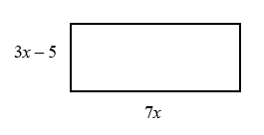**7** The diagram shows a rectangle.

Write down an expression, in terms of *x*, for the area of the rectangle.

Show that the area of the rectangle can be written as 21*x*2– 35*x*

**8** Expand and simplify.

**a** (*x* + 4)(*x* + 5) **b** (*x* + 7)(*x* + 3)

**c** (*x* + 7)(*x* – 2) **d** (*x* + 5)(*x* – 5)

**e** (2*x* + 3)(*x* – 1) **f** (3*x* – 2)(2*x* + 1)

**g** (5*x* – 3)(2*x* – 5) **h** (3*x* – 2)(7 + 4*x*)

**i** (3*x* + 4*y*)(5*y* + 6*x*) **j** (*x* + 5)2

**k** (2*x* − 7)2 **l** (4*x* − 3*y*)2

Extend

**9** Expand and simplify (*x* + 3)² + (*x* − 4)²

**10** Expand and simplify.

**a**  **b** 

**Week 1 - Factorising expressions**

<https://www.khanacademy.org/search?page_search_query=factorising>

<https://app.mymaths.co.uk/573-lesson/factorising-quadratics>

**A LEVEL LINKS**

Quadratic functions – factorising, solving, graphs and the discriminants

Key points

* Factorising an expression is the opposite of expanding the brackets.
* A quadratic expression is in the form *ax*2 + *bx* + *c*, where *a* ≠ 0.
* To factorise a quadratic equation find two numbers whose sum is *b* and whose product is *ac*.
* An expression in the form *x*2 – *y*2 is called the difference of two squares. It factorises to (*x* – *y*)(*x* + *y*).

Examples

**Example 1** Factorise 15*x*2*y*3 + 9*x*4*y*

|  |  |
| --- | --- |
| 15*x*2*y*3 + 9*x*4*y* = 3*x*2*y*(5*y*2 + 3*x*2) | The highest common factor is 3*x*2*y*. So take 3*x*2*y* outside the brackets and then divide each term by 3*x*2*y* to find the terms in the brackets |

**Example 2** Factorise 4*x*2 – 25*y*2

|  |  |
| --- | --- |
| 4*x*2 – 25*y*2 = (2*x* + 5*y*)(2*x* − 5*y*) | This is the difference of two squares as the two terms can be written as (2*x*)2and (5*y*)2 |

**Example 3** Factorise *x*2 + 3*x* – 10

|  |  |
| --- | --- |
| *b* = 3, *ac* = −10  So *x*2 + 3*x* – 10 = *x*2 + 5*x* – 2*x* – 10  = *x*(*x* + 5) – 2(*x* + 5)  = (*x* + 5)(*x* – 2) | **1** Work out the two factors of *ac*= −10 which add to give *b*= 3  (5 and −2)  **2** Rewrite the *b* term (3*x*) using these two factors  **3** Factorise the first two terms and the last two terms  **4** (*x* + 5) is a factor of both terms |

**Example 4** Factorise 6*x*2 − 11*x* − 10

|  |  |
| --- | --- |
| *b* = −11, *ac* = −60  So  6*x*2 − 11*x* – 10 =6*x*2 − 15*x* + 4*x* – 10  = 3*x*(2*x* − 5) + 2(2*x* − 5)  = (2*x* – 5)(3*x* + 2) | **1** Work out the two factors of *ac*= −60 which add to give *b*= −11 (−15 and 4)  **2** Rewrite the *b* term (−11*x*) using these two factors  **3** Factorise the first two terms and the last two terms  **4** (2*x* − 5) is a factor of both terms |

**Example 5** Simplify 

|  |  |
| --- | --- |
| For the numerator:  *b* = −4, *ac* = −21  So  *x*2 − 4*x* – 21 = *x*2 − 7*x* + 3*x* – 21  = *x*(*x* − 7) + 3(*x* − 7)  = (*x* – 7)(*x* + 3)  For the denominator:  *b* = 9, *ac* = 18  So  2*x*2 + 9*x* + 9 = 2*x*2 + 6*x* + 3*x* + 9  = 2*x*(*x* + 3) + 3(*x* + 3)  = (*x* + 3)(2*x* + 3)  So    = | **1** Factorise the numerator and the denominator  **2** Work out the two factors of *ac*= −21 which add to give *b*= −4 (−7 and 3)  **3** Rewrite the *b* term (−4*x*) using these two factors  **4** Factorise the first two terms and the last two terms  **5** (*x* − 7) is a factor of both terms  **6** Work out the two factors of  *ac*= 18 which add to give *b*= 9  (6 and 3)  **7** Rewrite the *b* term (9*x*) using these two factors  **8** Factorise the first two terms and the last two terms  **9** (*x* + 3) is a factor of both terms  **10** (*x* + 3) is a factor of both the numerator and denominator so cancels out as a value divided by itself is 1 |

Practice

**1** Factorise.

**Hint**

Take the highest common factor outside the bracket.

**a** 6*x*4*y*3 – 10*x*3*y*4 **b** 21*a*3*b*5 + 35*a*5*b*2

**c** 25*x*2*y*2 – 10*x*3*y*2 + 15*x*2*y*3

**2** Factorise

**a** *x*2 + 7*x* + 12 **b** *x*2 + 5*x* – 14

**c** *x*2 – 11*x* + 30 **d** *x*2 – 5*x* – 24

**e** *x*2 – 7*x* – 18 **f** *x*2 + *x* –20

**g** *x*2 – 3*x* – 40 **h** *x*2 + 3*x* – 28

**3** Factorise

**a** 36*x*2 – 49*y*2 **b** 4*x*2 – 81*y*2

**c** 18*a*2 – 200*b*2*c*2

**4** Factorise

**a** 2*x*2 + *x* –3 **b** 6*x*2 + 17*x* + 5

**c** 2*x*2 + 7*x* + 3 **d** 9*x*2 – 15*x* + 4

**e** 10*x*2 + 21*x* + 9 **f** 12*x*2 – 38*x* + 20

**5** Simplify the algebraic fractions.

**a**  **b** 

**c**  **d** 

**e**  **f** 

**6** Simplify

**a**  **b** 

**c**  **d** 

# **Extend**

**7** Simplify 

**8** Simplify 

**Week 1 - Completing the square**

<https://www.khanacademy.org/search?page_search_query=completing%20the%20square>

**A LEVEL LINKS**

Quadratic functions – factorising, solving, graphs and the discriminants

Key points

* Completing the square for a quadratic rearranges *ax*2 + *bx* + *c* into the form *p*(*x* + *q*)2 + *r*
* If *a* ≠ 1, then factorise using *a* as a common factor.

Examples

**Example 1** Complete the square for the quadratic expression *x*2 + 6*x* − 2

|  |  |
| --- | --- |
| *x*2 + 6*x* − 2  = (*x* + 3)2 − 9 − 2  = (*x* + 3)2 − 11 | **1** Write *x*2 + *bx* + *c* in the form  **2** Simplify |

**Example 2** Write 2*x*2 − 5*x* + 1 in the form *p*(*x* + *q*)2 + *r*

|  |  |
| --- | --- |
| 2*x*2 − 5*x* + 1  =  =  =  = | **1** Before completing the square write *ax*2 + *bx* + *c* in the form  **2** Now complete the square by writing  in the form  **3** Expand the square brackets – don’t forget to multiply by the factor of 2  **4** Simplify |

Practice

**1** Write the following quadratic expressions in the form (*x* + *p*)2 + *q*

**a** *x*2 + 4*x* + 3 **b** *x*2 – 10*x* – 3

**c** *x*2 – 8*x* **d** *x*2 + 6*x*

**e** *x*2 – 2*x* + 7 **f** *x*2 + 3*x* – 2

**2** Write the following quadratic expressions in the form *p*(*x* + *q*)2 + *r*

**a** 2*x*2 – 8*x* – 16 **b** 4*x*2 – 8*x* – 16

**c** 3*x*2 + 12*x* – 9 **d** 2*x*2 + 6*x* – 8

**3** Complete the square.

**a** 2*x*2 + 3*x* + 6 **b** 3*x*2 – 2*x*

**c** 5*x*2 + 3*x* **d** 3*x*2 + 5*x* + 3

Extend

**4** Write (25*x*2 + 30*x* + 12) in the form (*ax* + *b*)2 + *c*.

**Week 1 - Solving quadratic equations by factorisation**

<https://www.khanacademy.org/search?page_search_query=solving%20quadratics%20by%20factoring>

<https://app.mymaths.co.uk/574-lesson/solving-quadratics>

**A LEVEL LINKS**

Quadratic functions – factorising, solving, graphs and the discriminants

Key points

* A quadratic equation is an equation in the form *ax*2 + *bx* + *c* = 0 where *a* ≠ 0.
* To factorise a quadratic equation find two numbers whose sum is *b* and whose products is *ac*.
* When the product of two numbers is 0, then at least one of the numbers must be 0.
* If a quadratic can be solved it will have two solutions (these may be equal).

Examples

**Example 1** Solve 5*x*2 = 15*x*

|  |  |
| --- | --- |
| 5*x*2 = 15*x*  5*x*2 − 15*x* = 0  5*x*(*x* − 3) = 0  So 5*x* = 0 or (*x* − 3) = 0  Therefore *x* = 0 or *x* = 3 | **1** Rearrange the equation so that all of the terms are on one side of the equation and it is equal to zero.  Do not divide both sides by *x* as this would lose the solution *x* = 0.  **2** Factorise the quadratic equation.  5*x* is a common factor.  **3** When two values multiply to make zero, at least one of the values must be zero.  **4** Solve these two equations. |

**Example 2** Solve *x*2 + 7*x* + 12 = 0

|  |  |
| --- | --- |
| *x*2 + 7*x* + 12 = 0  *b* = 7, *ac* = 12  *x*2 + 4*x* + 3*x* + 12 = 0  *x*(*x* + 4) + 3(*x* + 4) = 0  (*x* + 4)(*x* + 3) = 0  So (*x* + 4)= 0 or (*x* + 3) = 0  Therefore *x* = −4 or *x* = −3 | **1** Factorise the quadratic equation. Work out the two factors of *ac* = 12 which add to give you *b* = 7.  (4 and 3)  **2** Rewrite the *b* term (7*x*) using these two factors.  **3** Factorise the first two terms and the last two terms.  **4** (*x* + 4) is a factor of both terms.  **5** When two values multiply to make zero, at least one of the values must be zero.  **6** Solve these two equations. |

**Example 3** Solve 9*x*2 − 16 = 0

|  |  |
| --- | --- |
| 9*x*2 − 16 = 0  (3*x* + 4)(3*x* – 4) = 0  So (3*x* + 4) = 0 or (3*x* – 4) = 0  or | **1** Factorise the quadratic equation. This is the difference of two squares as the two terms are (3*x*)2 and (4)2.  **2** When two values multiply to make zero, at least one of the values must be zero.  **3** Solve these two equations. |

**Example 4** Solve 2*x*2 − 5*x* − 12 = 0

|  |  |
| --- | --- |
| *b* = −5, *ac* = −24  So 2*x*2 − 8*x* + 3*x* – 12 = 0  2*x*(*x* − 4) + 3(*x* − 4) = 0  (*x* – 4)(2*x* + 3) = 0  So (*x* – 4) = 0 or (2*x* +3) = 0  or | **1** Factorise the quadratic equation. Work out the two factors of *ac* = −24 which add to give you *b* = −5.  (−8 and 3)  **2** Rewrite the *b* term (−5*x*) using these two factors.  **3** Factorise the first two terms and the last two terms.  **4** (*x* − 4) is a factor of both terms.  **5** When two values multiply to make zero, at least one of the values must be zero.  **6** Solve these two equations. |

Practice

**1** Solve

**a** 6*x*2 + 4*x* = 0 **b** 28*x*2 – 21*x* = 0

**c** *x*2 + 7*x* + 10 = 0 **d** *x*2 – 5*x* + 6 = 0

**e** *x*2 – 3*x* – 4 = 0 **f** *x*2 + 3*x* – 10 = 0

**g** *x*2 – 10*x* + 24 = 0 **h** *x*2 – 36 = 0

**i** *x*2 + 3*x* – 28 = 0 **j** *x*2 – 6*x* + 9 = 0

**k** 2*x*2 – 7*x* – 4 = 0 **l** 3*x*2 – 13*x* – 10 = 0

**2** Solve

**Hint**

Get all terms onto one side of the equation.

**a** *x*2 – 3*x* = 10 **b** *x*2 – 3 = 2*x*

**c** *x*2 + 5*x* = 24 **d** *x*2 – 42 = *x*

**e** *x*(*x* + 2) = 2*x* + 25 **f** *x*2 – 30 = 3*x* – 2

**g** *x*(3*x* + 1) = *x*2 + 15 **h** 3*x*(*x* – 1) = 2(*x* + 1)

**Week 1 - Solving quadratic equations by completing the square**

<https://www.khanacademy.org/search?page_search_query=completing%20the%20square>

<https://app.mymaths.co.uk/576-lesson/completing-the-square>

**A LEVEL LINKS**

Quadratic functions – factorising, solving, graphs and the discriminants

Key points

* Completing the square lets you write a quadratic equation in the form *p*(*x* + *q*)2 + *r* = 0*.*

Examples

**Example 5** Solve *x*2 + 6*x* + 4 = 0. Give your solutions in surd form.

|  |  |
| --- | --- |
| *x*2 + 6*x* + 4 = 0  (*x* + 3)2 − 9 + 4 = 0  (*x* + 3)2 − 5 = 0  (*x* + 3)2 = 5  *x* + 3 =  *x* =  So *x* =  or *x* = | **1** Write *x*2 + *bx* + *c* = 0 in the form  **2** Simplify.  **3** Rearrange the equation to work out *x*. First, add 5 to both sides.  **4** Square root both sides.  Remember that the square root of a value gives two answers.  **5** Subtract 3 from both sides to solve the equation.  **6** Write down both solutions. |

**Example 6** Solve 2*x*2 − 7*x* + 4 = 0. Give your solutions in surd form.

|  |  |
| --- | --- |
| 2*x*2 − 7*x* + 4 = 0  = 0  = 0  = 0  = 0          So  or | **1** Before completing the square write *ax*2 + *bx* + *c* in the form  **2** Now complete the square by writing  in the form  **3** Expand the square brackets.  **4** Simplify.  *(continued on next page)*  **5** Rearrange the equation to work out *x*. First, add  to both sides.  **6** Divide both sides by 2.  **7** Square root both sides. Remember that the square root of a value gives two answers.  **8** Add  to both sides.  **9** Write down both the solutions. |

Practice

**3** Solve by completing the square.

**a** *x*2 – 4*x* – 3 = 0 **b** *x*2 – 10*x* + 4 = 0

**c** *x*2 + 8*x* – 5 = 0 **d** *x*2 – 2*x* – 6 = 0

**e** 2*x*2 + 8*x* – 5 = 0 **f** 5*x*2 + 3*x* – 4 = 0

**4** Solve by completing the square.

**Hint**

Get all terms onto one side of the equation.

**a** (*x* – 4)(*x* + 2) = 5

**b** 2*x*2 + 6*x* – 7 = 0

**c** *x*2 – 5*x* + 3 = 0

**Week 1 - Solving quadratic equations by using the formula**

<https://www.khanacademy.org/search?page_search_query=quadratic%20formula>

<https://app.mymaths.co.uk/575-lesson/quadratic-formula>

**A LEVEL LINKS**

Quadratic functions – factorising, solving, graphs and the discriminants

Key points

* Any quadratic equation of the form *ax*2 + *bx* + *c* = 0 can be solved using the formula 
* If *b*2 – 4*ac* is negative then the quadratic equation does not have any real solutions.
* It is useful to write down the formula before substituting the values for *a*, *b* and *c*.

Examples

**Example 7** Solve *x*2 + 6*x* + 4 = 0. Give your solutions in surd form.

|  |  |
| --- | --- |
| *a* = 1, *b* = 6, *c* = 4            So  or | **1** Identify *a*, *b* and *c* and write down the formula.  Remember that  is all over 2*a*, not just part of it.  **2** Substitute *a* = 1, *b* = 6, *c* = 4 into the formula.  **3** Simplify. The denominator is 2, but this is only because *a* = 1. The denominator will not always be 2.  **4** Simplify .  **5** Simplify by dividing numerator and denominator by 2.  **6** Write down both the solutions. |

**Example 8** Solve 3*x*2 − 7*x* − 2 = 0. Give your solutions in surd form.

|  |  |
| --- | --- |
| *a* = 3, *b* = −7, *c* = −2        So  or | **1** Identify *a*, *b* and *c*, making sure you get the signs right and write down the formula.  Remember that  is all over 2*a*, not just part of it.  **2** Substitute *a* = 3, *b* = −7, *c* = −2 into the formula.  **3** Simplify. The denominator is 6 when *a* = 3. A common mistake is to always write a denominator of 2.  **4** Write down both the solutions. |

Practice

**5** Solve, giving your solutions in surd form.

**a** 3*x*2 + 6*x* + 2 = 0 **b** 2*x*2 – 4*x* – 7 = 0

**6** Solve the equation *x*2 – 7*x* + 2 = 0

Give your solutions in the form , where *a*, *b* and *c* are integers.

**7** Solve 10*x*2 + 3*x* + 3 = 5

**Hint**

Get all terms onto one side of the equation.

Give your solution in surd form.

Extend

**8** Choose an appropriate method to solve each quadratic equation, giving your answer in surd form when necessary.

**a** 4*x*(*x* – 1) = 3*x* – 2

**b** 10 = (*x* + 1)2

**c** *x*(3*x* – 1) = 10

**Week 2 - Sketching quadratic graphs**

<https://www.khanacademy.org/search?search_again=1&page_search_query=sketching+quadratic+graphs>

<https://app.mymaths.co.uk/3272-lesson/sketching-quadratic-graphs-1>

**A LEVEL LINKS**

Quadratic functions – factorising, solving, graphs and the discriminants

Key points

* The graph of the quadratic function   
  *y* = *ax*2 + *bx* + *c*, where *a* ≠ 0, is a curve   
  called a parabola.

for *a* < 0

for *a* > 0

* Parabolas have a line of symmetry and   
  a shape as shown.
* To sketch the graph of a function, find the points where the graph intersects the axes.
* To find where the curve intersects the *y*-axis substitute *x* = 0 into the function.
* To find where the curve intersects the *x*-axis substitute *y* = 0 into the function.
* At the turning points of a graph the gradient of the curve is 0 and any tangents to the curve at these points are horizontal.
* To find the coordinates of the maximum or minimum point (turning points) of a quadratic curve (parabola) you can use the completed square form of the function.

Examples

**Example 1** Sketch the graph of *y* = *x*2.

|  |  |
| --- | --- |
|  | The graph of *y* = *x*2 is a parabola.  When *x* = 0, *y* = 0.  *a* = 1 which is greater than zero, so the graph has the shape: |

**Example 2** Sketch the graph of *y* = *x*2 − *x* − 6.

|  |  |
| --- | --- |
| When *x* = 0, *y* = 02 − 0 − 6 = −6  So the graph intersects the *y*-axis at  (0, −6)  When *y* = 0, *x*2 − *x* − 6 = 0  (*x* + 2)(*x* − 3) = 0  *x* = −2 or *x* = 3  So,  the graph intersects the *x*-axis at (−2, 0) and (3, 0)  *x*2 − *x* − 6 =  =  When ,  and , so the turning point is at the point | **1** Find where the graph intersects the *y*-axis by substituting *x* = 0.  **2** Find where the graph intersects the *x*-axis by substituting *y* = 0.  **3** Solve the equation by factorising.  **4** Solve (*x* + 2) = 0 and (*x* − 3) = 0.  **5** *a* = 1 which is greater than zero, so the graph has the shape:  *(continued on next page)*  **6** To find the turning point, complete the square.  **7** The turning point is the minimum value for this expression and occurs when the term in the bracket is equal to zero. |

Practice

**1** Sketch the graph of *y* = −*x*2.

**2** Sketch each graph, labelling where the curve crosses the axes.

**a** *y* = (*x* + 2)(*x* − 1) **b** *y* = *x*(*x* − 3) **c** *y* = (*x* + 1)(*x* + 5)

**3** Sketch each graph, labelling where the curve crosses the axes.

**a** *y* = *x*2 − *x* − 6 **b** *y* = *x*2 − 5*x* + 4 **c** *y* = *x*2 – 4

**d** *y* = *x*2 + 4*x* **e** *y* = 9 − *x*2 **f** *y* = *x*2 + 2*x* − 3

**4** Sketch the graph of *y* = 2*x*2 + 5*x* − 3, labelling where the curve crosses the axes.

Extend

**5** Sketch each graph. Label where the curve crosses the axes and write down the coordinates of the turning point.

**a** *y* = *x*2 − 5*x* + 6 **b** *y* = −*x*2 + 7*x* − 12 **c** *y* = −*x*2 + 4*x*

**6** Sketch the graph of *y* = *x*2 + 2*x* + 1. Label where the curve crosses the axes and write down the equation of the line of symmetry.

**Week 2 - Straight line graphs**

<https://www.khanacademy.org/search?search_again=1&page_search_query=linear+graphs>

<https://app.mymaths.co.uk/3265-lesson/transforming-graphs-1>

**A LEVEL LINKS**

Straight-line graphs, parallel/perpendicular, length and area problems

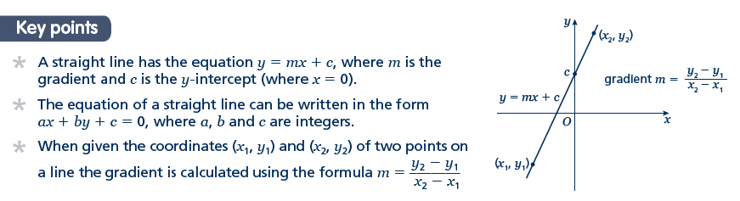Key points

* A straight line has the equation *y* = *mx* + *c*, where *m* is the gradient and *c* is the *y*-intercept (where *x* = 0).
* The equation of a straight line can be written in the form *ax* + *by* + *c* = 0, where *a*, *b* and *c* are integers.
* When given the coordinates (*x*1, *y*1) and (*x*2, *y*2) of two points on a line the gradient is calculated using the formula 

Examples

**Example 1** A straight line has gradient  and *y*-intercept 3.  
Write the equation of the line in the form *ax* + *by* + *c* = 0.

|  |  |
| --- | --- |
| *m* =  and *c* = 3  So *y* = *x* + 3  *x* + *y* – 3 = 0  *x* + 2*y* − 6 = 0 | **1** A straight line has equation *y*= *mx*+ *c*. Substitute the gradient and *y*-intercept given in the question into thisequation.  **2** Rearrange the equation so all the terms are on one side and 0 is on  the other side.  **3** Multiply both sides by 2 to eliminate the denominator. |

**Example 2** Find the gradient and the *y*-intercept of the line with the equation 3*y* − 2*x* + 4 = 0.

|  |  |
| --- | --- |
| 3*y* − 2*x* + 4 = 0  3*y* = 2*x* − 4    Gradient = *m* =  *y*-intercept = *c* = | **1** Make *y* the subject of the equation.  **2** Divide all the terms by three to get the equation in the form *y* = …  **3** In the form *y* = *mx* + *c*, the gradient is *m* and the *y*-intercept is *c*. |

**Example 3** Find the equation of the line which passes through the point (5, 13) and has gradient 3.

|  |  |
| --- | --- |
| *m* = 3  *y* = 3*x* + *c*  13 = 3 × 5 + *c*  13 = 15 + *c*  *c* = −2  *y* = 3*x* − 2 | **1** Substitute the gradient given in the question into the equation of a straight line *y* = *mx* + *c*.  **2** Substitute the coordinates *x* = 5 and *y* = 13 into the equation.  **3** Simplify and solve the equation.  **4** Substitute *c* = −2 into the equation *y*= 3*x*+ *c* |

**Example 4** Find the equation of the line passing through the points with coordinates (2, 4) and (8, 7).

|  |  |
| --- | --- |
| , ,  and        *c* = 3 | **1** Substitute the coordinates into the equation  to work out the gradient of the line.  **2** Substitute the gradient into the equation of a straight line *y*= *mx*+ *c*.  **3** Substitute the coordinates of either point into the equation.  **4** Simplify and solve the equation.  **5** Substitute *c* = 3 into the equation |

Practice

**1** Find the gradient and the *y*-intercept of the following equations.

**a** *y* = 3*x* + 5 **b** *y* = *x* – 7

**Hint**

Rearrange the equations to the form *y* = *mx* + *c*

**c** 2*y* = 4*x* – 3 **d** *x* + *y* = 5

**e** 2*x* – 3*y* – 7 = 0 **f** 5*x* + *y* – 4 = 0

**2** Copy and complete the table, giving the equation of the line in the form *y* = *mx* + *c*.

|  |  |  |
| --- | --- | --- |
| **Gradient** | ***y*-intercept** | **Equation of the line** |
| 5 | 0 |  |
| –3 | 2 |  |
| 4 | –7 |  |

**3** Find, in the form *ax* + *by* + *c* = 0 where *a*, *b* and *c* are integers, an equation for each of the lines with the following gradients and *y*-intercepts.

**a** gradient , *y*-intercept –7 **b** gradient 2, *y*-intercept 0

**c** gradient , *y*-intercept 4 **d** gradient –1.2, *y*-intercept –2

**4** Write an equation for the line which passes though the point (2, 5) and has gradient 4.

**5** Write an equation for the line which passes through the point (6, 3) and has gradient 

**6** Write an equation for the line passing through each of the following pairs of points.

**a** (4, 5), (10, 17) **b** (0, 6), (–4, 8)

**c** (–1, –7), (5, 23) **d** (3, 10), (4, 7)

Extend

**7** The equation of a line is 2*y* + 3*x* – 6 = 0.  
Write as much information as possible about this line.

**Week 2 - Parallel and perpendicular lines**

<https://www.khanacademy.org/search?search_again=1&page_search_query=equations+of+parallel+and+perpendicular+lines>

<https://app.mymaths.co.uk/557-lesson/gradients>

**A LEVEL LINKS**

Straight-line graphs, parallel/perpendicular, length and area problems

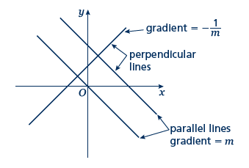Key points

* When lines are parallel they have the same gradient.
* A line perpendicular to the line with equation *y* = *mx* + *c* has gradient .

Examples

**Example 1** Find the equation of the line parallel to *y* = 2*x* + 4 which passes through   
the point (4, 9).

|  |  |
| --- | --- |
| *y* = 2*x* + 4  *m* = 2  *y* = 2*x* + *c*  9 = 2 × 4 + *c*  9 = 8 + *c*  *c* = 1  *y* = 2*x* + 1 | **1** As the lines are parallel they have the same gradient.  **2** Substitute *m* = 2 into the equation of a straight line *y* = *mx* + *c*.  **3** Substitute the coordinates into the equation *y* = 2*x* + *c*  **4** Simplify and solve the equation.  **5** Substitute *c* = 1 into the equation *y*= 2*x* + *c* |

**Example 2** Find the equation of the line perpendicular to *y* = 2*x* − 3 which passes through   
the point (−2, 5).

|  |  |
| --- | --- |
| *y* = 2*x* − 3  *m* = 2        5 = 1 + *c*  *c* = 4 | **1** As the lines are perpendicular, the gradient of the perpendicular line  is .  **2** Substitute *m* =  into *y* = *mx* + *c*.  **3** Substitute the coordinates (–2, 5) into the equation  **4** Simplify and solve the equation.  **5** Substitute *c* = 4 into . |

**Example 3** A line passes through the points (0, 5) and (9, −1).  
Find the equation of the line which is perpendicular to the line and passes through   
its midpoint.

|  |  |
| --- | --- |
| , ,  and        Midpoint = | **1** Substitute the coordinates into the equation  to work out the gradient of the line.  **2** As the lines are perpendicular, the gradient of the perpendicular line  is .  **3** Substitute the gradient into the equation *y* = *mx* + *c*.  **4** Work out the coordinates of the midpoint of the line.  **5** Substitute the coordinates of the midpoint into the equation.  **6** Simplify and solve the equation.  **7** Substitute  into the equation . |

Practice

**1** Find the equation of the line parallel to each of the given lines and which passes through each of the given points.

**a** *y* = 3*x* + 1 (3, 2) **b** *y* = 3 – 2*x* (1, 3)

**c** 2*x* + 4*y* + 3 = 0 (6, –3) **d** 2*y* –3*x* + 2 = 0 (8, 20)

**2** Find the equation of the line perpendicular to *y* = *x* – 3 which passes through the point (–5, 3).

**Hint**

If *m* =  then the negative reciprocal 

**3** Find the equation of the line perpendicular to each of the given lines and which passes through each of the given points.

**a** *y* = 2*x* – 6 (4, 0) **b** *y* = *x* +  (2, 13)

**c** *x* –4*y* – 4 = 0 (5, 15) **d** 5*y* + 2*x* – 5 = 0 (6, 7)

**4** In each case find an equation for the line passing through the origin which is also perpendicular to the line joining the two points given.

**a** (4, 3), (–2, –9) **b** (0, 3), (–10, 8)

Extend

**5** Work out whether these pairs of lines are parallel, perpendicular or neither.

**a** *y* = 2*x* + 3 **b** *y* = 3*x* **c** *y* = 4*x* – 3  
 *y* = 2*x* – 7 2*x + y* – 3 = 0 4*y* + *x* = 2

**d** 3*x* – *y* + 5 = 0 **e** 2*x* + 5*y* – 1 = 0 **f** 2*x* – *y* = 6

*x* + 3*y* = 1 *y* = 2*x* + 7 6*x* – 3*y* + 3 = 0

**6** The straight line **L1** passes through the points *A* and *B* with coordinates (–4, 4) and (2, 1), respectively.

**a** Find the equation of **L1** in the form *ax* + *by* + *c* = 0

The line **L2** is parallel to the line **L1** and passes through the point *C* with coordinates (–8, 3).

**b** Find the equation of **L2** in the form *ax* + *by* + *c* = 0

The line **L3** is perpendicular to the line **L1** and passes through the origin.

**c** Find an equation of **L3**

**Week 2 - Pythagoras’ theorem**

<https://www.khanacademy.org/search?page_search_query=Pythagoras%20theorem>

<https://app.mymaths.co.uk/300-lesson/pythagoras-theorem>

**A LEVEL LINKS**

Straight-line graphs, parallel/perpendicular, length and area problems

Key points

* 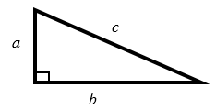In a right-angled triangle the longest side is called the hypotenuse.
* Pythagoras’ theorem states that for a right-angled triangle the square of the hypotenuse is equal to the sum of the squares of the other two sides.  
  *c*2 = *a*2 + *b*2

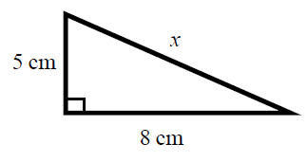Examples

**Example 1** Calculate the length of the hypotenuse.  
Give your answer to 3 significant figures.

|  |  |
| --- | --- |
| *c*2 = *a*2 + *b*2    *x*2 = 52 + 82  *x*2 = 25 + 64  *x*2 = 89    *x* = 9.433 981 13...  *x* = 9.43 cm | **1** Always start by stating the formula for Pythagoras’ theorem and labelling the hypotenuse *c* and the other two sides *a* and *b*.  **2** Substitute the values of *a*, *b* and *c* into the formula for Pythagoras' theorem.  **3** Use a calculator to find the square root.  **4** Round your answer to 3 significant figures and write the units with your answer. |

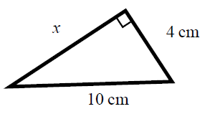**Example 2** Calculate the length *x*.   
Give your answer in surd form.

|  |  |
| --- | --- |
| *c*2 = *a*2 + *b*2  102 = *x*2 + 42  100 = *x*2 + 16  *x*2 = 84    cm | **1** Always start by stating the formula for Pythagoras' theorem.  **2** Substitute the values of *a*, *b* and *c* into the formula for Pythagoras' theorem.  **3** Simplify the surd where possible and write the units in your answer. |

Practice

**1** Work out the length of the unknown side in each triangle.  
 Give your answers correct to 3 significant figures.

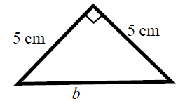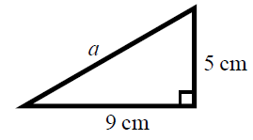 **a b**

**c d**

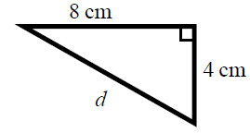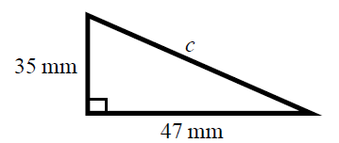

**2** Work out the length of the unknown side in each triangle.  
 Give your answers in surd form.

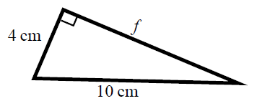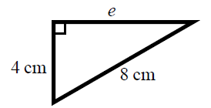 **a b**

**c d**

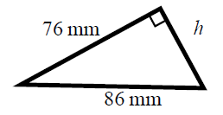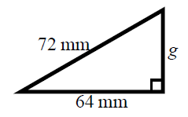

**3** Work out the length of the unknown side in each triangle.   
 Give your answers in surd form.

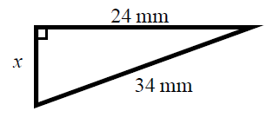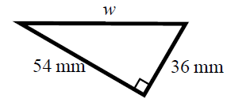 **a b**

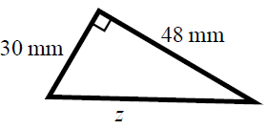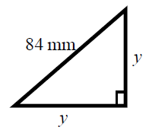 **c d**

**4** A rectangle has length 84 mm and width 45 mm.   
 Calculate the length of the diagonal of the rectangle.  
 Give your answer correct to 3 significant figures.

**Hint**

Draw a sketch of the rectangle.

Extend

**5** A yacht is 40 km due North of a lighthouse.  
A rescue boat is 50 km due East of the same lighthouse.  
Work out the distance between the yacht and the rescue boat.  
Give your answer correct to 3 significant figures.

**Hint**

Draw a diagram using the information given in the question.

**6** Points A and B are shown on the diagram.  
Work out the length of the line AB.   
Give your answer in surd form.

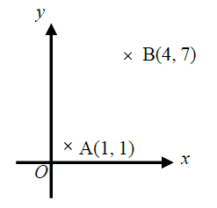

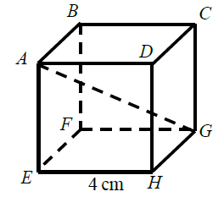**7** A cube has length 4 cm.   
Work out the length of the diagonal *AG*.  
Give your answer in surd form.

**Week 2 - Circle theorems**

<https://www.khanacademy.org/search?page_search_query=circle%20theorems>

<https://app.mymaths.co.uk/273-lesson/circle-theorems>

**A LEVEL LINKS**

Circles – equation of a circle, geometric problems on a grid

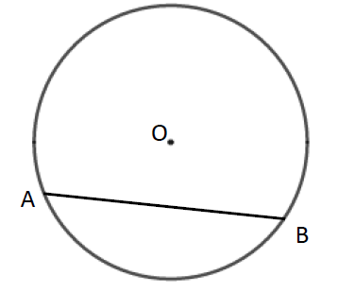Key points

* A chord is a straight line joining two points on the circumference of a circle.  
  So AB is a chord.

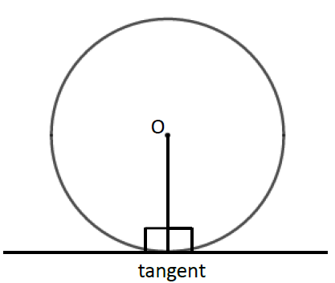

* A tangent is a straight line that touches the circumference of a circle at only one point.  
  The angle between a tangent and the radius is 90°.

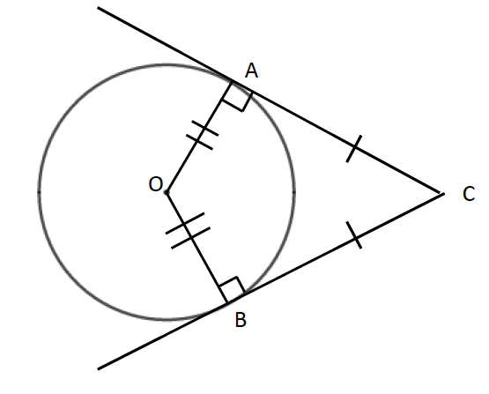

* Two tangents on a circle that meet at a point outside the circle are equal in length.  
  So AC = BC.

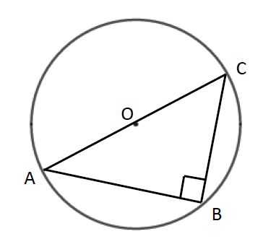

* The angle in a semicircle is a right angle.  
  So angle ABC = 90°.

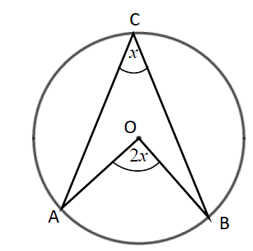

* When two angles are subtended by the same arc, the angle at the centre of a circle is twice the angle at the circumference.  
  So angle AOB = 2 × angle ACB.
* 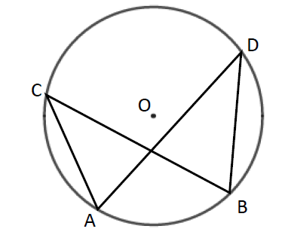Angles subtended by the same arc at the circumference are equal. This means that angles in the same segment are equal.   
  So angle ACB = angle ADB and   
  angle CAD = angle CBD.

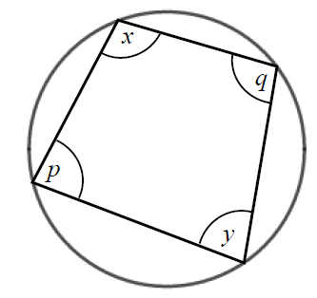

* A cyclic quadrilateral is a quadrilateral with all four vertices on the circumference of a circle.  
  Opposite angles in a cyclic quadrilateral total 180°.  
  So *x* + *y* = 180° and *p* + *q* = 180°.

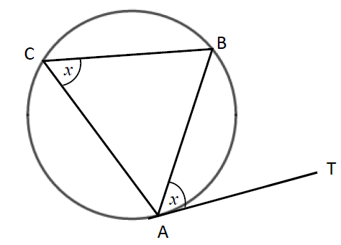

* The angle between a tangent and chord is equal to the angle in the alternate segment, this is known as the alternate segment theorem.  
  So angle BAT = angle ACB.

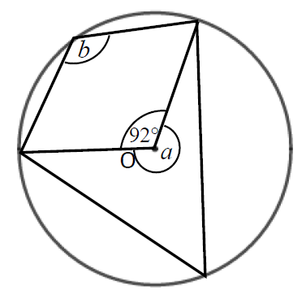Examples

**Example 1** Work out the size of each angle   
marked with a letter.  
Give reasons for your answers.

|  |  |
| --- | --- |
| Angle *a* = 360° − 92°  = 268°  as the angles in a full turn total 360°.  Angle *b* = 268° ÷ 2  = 134° as when two angles are subtended by the same arc, the angle at the centre of a circle is twice the angle at the circumference. | **1** The angles in a full turn total 360°.  **2** Angles *a* and *b* are subtended by  the same arc, so angle *b* is half of angle *a*. |

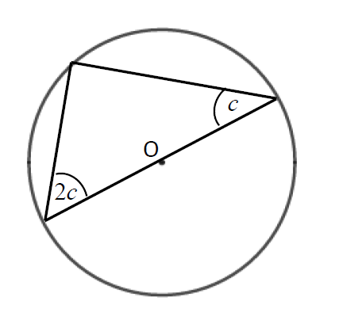**Example 2** Work out the size of the angles in the triangle.  
 Give reasons for your answers.

|  |  |
| --- | --- |
| Angles are 90°, 2*c* and *c*.  90° + 2*c* + *c* = 180°  90° + 3*c* = 180°  3*c* = 90°  *c* = 30°  2*c* = 60°  The angles are 30°, 60° and 90° as the angle in a semi-circle is a right angle and the angles in a triangle total 180°. | **1** The angle in a semicircle is a right angle.  **2** Angles in a triangle total 180°.  **3** Simplify and solve the equation. |

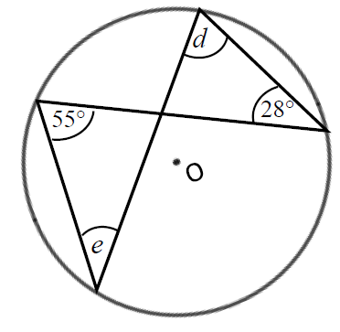

**Example 3** Work out the size of each angle marked with a letter.  
 Give reasons for your answers.

|  |  |
| --- | --- |
| Angle *d* = 55° as angles subtended by the same arc are equal.  Angle *e* = 28° as angles subtended by the same arc are equal. | **1** Angles subtended by the same arc are equal so angle 55° and angle *d* are equal.  **2** Angles subtended by the same arc are equal so angle 28° and angle *e* are equal. |

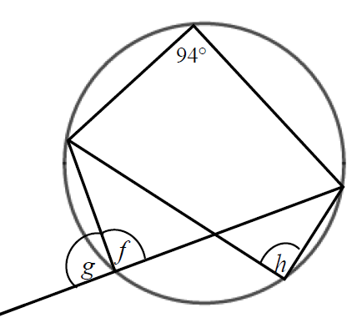

**Example 4** Work out the size of each angle marked with a letter.  
 Give reasons for your answers.

|  |  |
| --- | --- |
| Angle *f* = 180° − 94°  = 86°  as opposite angles in a cyclic quadrilateral total 180°. | **1** Opposite angles in a cyclic quadrilateral total 180° so angle 94° and angle *f* total 180°.  *(continued on next page)* |
| Angle *g* = 180° − 86°  = 84°  as angles on a straight line total 180°.  Angle *h* = angle *f* = 86° as angles subtended by the same arc are equal. | **2** Angles on a straight line total 180° so angle *f* and angle *g* total 180°.  **3** Angles subtended by the same arc are equal so angle *f* and angle *h* are equal. |

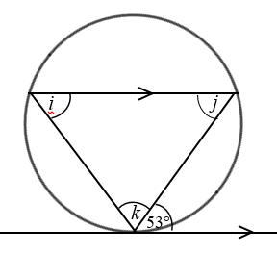

**Example 5** Work out the size of each angle marked with a letter.  
 Give reasons for your answers.

|  |  |
| --- | --- |
| Angle *i* = 53° because of the alternate segment theorem.  Angle *j* = 53° because it is the alternate angle to 53°.  Angle *k* = 180° − 53° − 53°  = 74°  as angles in a triangle total 180°. | **1** The angle between a tangent and chord is equal to the angle in the alternate segment.  **2** As there are two parallel lines, angle 53° is equal to angle *j* because they are alternate angles.  **3** The angles in a triangle total 180°, so *i* + *j* + *k* = 180°. |

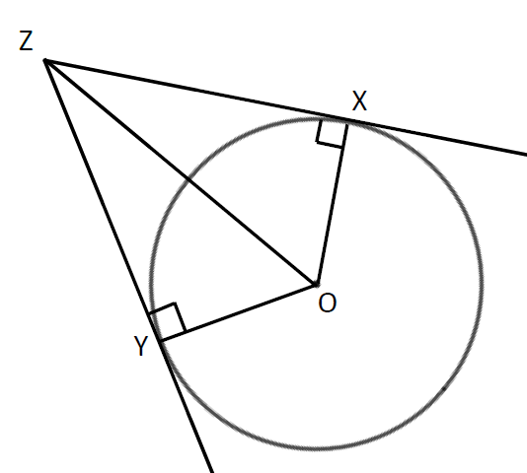

**Example 6** XZ and YZ are two tangents to a circle with centre O.  
 Prove that triangles XZO and YZO are congruent.

|  |  |
| --- | --- |
| Angle OXZ = 90° and angle OYZ = 90° as the angles in a semicircle are right angles.  OZ is a common line and is the hypotenuse in both triangles.  OX = OY as they are radii of the same circle.  So triangles XZO and YZO are congruent, RHS. | For two triangles to be congruent you need to show one of the following.   * All three corresponding sides are equal (SSS). * Two corresponding sides and the included angle are equal (SAS). * One side and two corresponding angles are equal (ASA). * A right angle, hypotenuse and a shorter side are equal (RHS). |

Practice

**1** Work out the size of each angle marked with a letter.

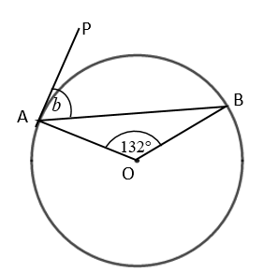 Give reasons for your answers.

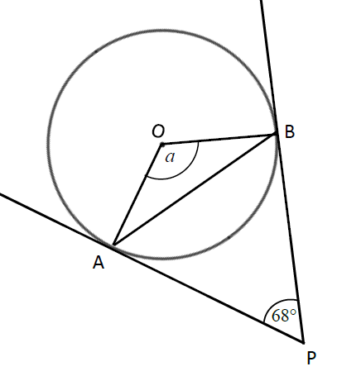 **a b**

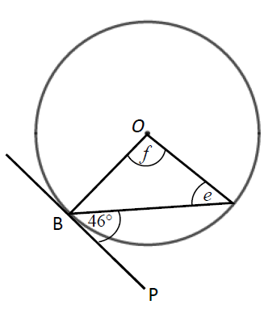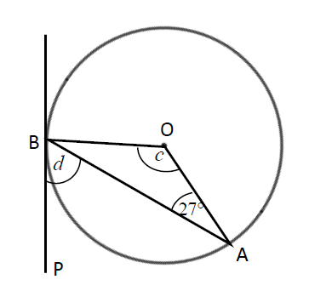

**c d**

A

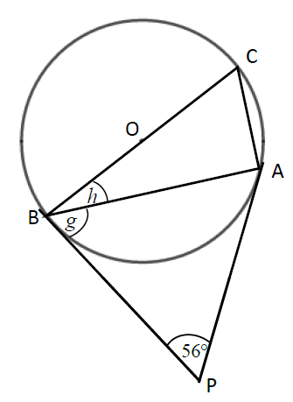 **e**

**2** Work out the size of each angle marked with a letter.  
 Give reasons for your answers.

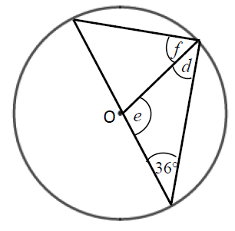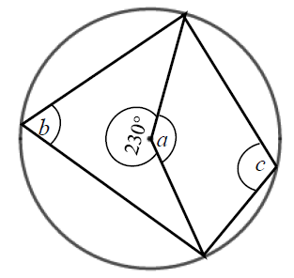 **a b**

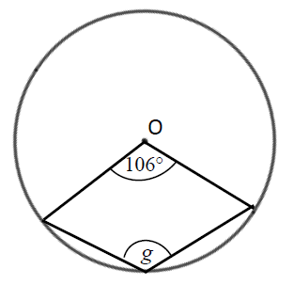

**c**

**Hint**

The reflex angle at point O and angle *g* are subtended by the same arc. So the reflex angle is twice the size of angle *g*.

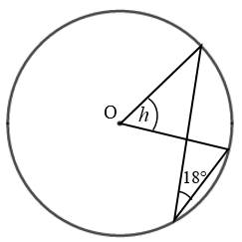 **d**

**Hint**

Angle 18° and angle *h* are subtended by the same arc.

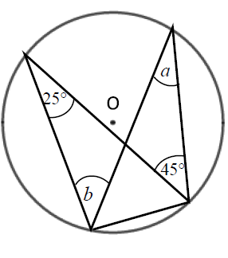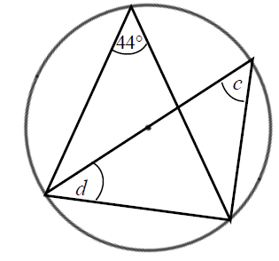**3** Work out the size of each angle marked with a letter.  
 Give reasons for your answers.

**a b**

**Hint**

One of the angles is in a semicircle.

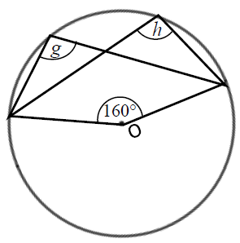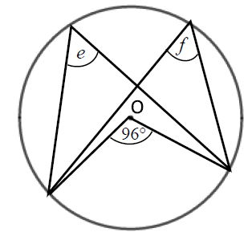

**c d**

**4** Work out the size of each angle marked with a letter.  
 Give reasons for your answers.

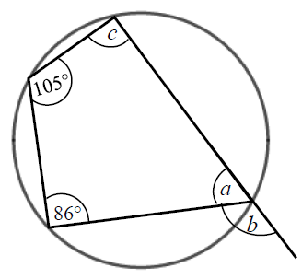 **a**

**Hint**

An exterior angle of a cyclic quadrilateral is equal to the opposite interior angle.

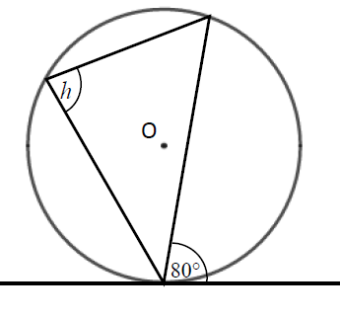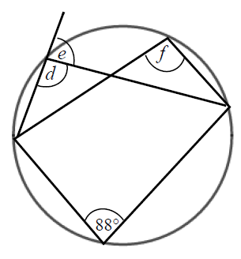 **b c**

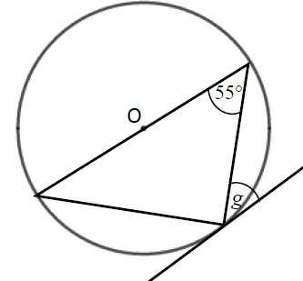 **d**

**Hint**

One of the angles is in a semicircle.

Extend

**5** Prove the alternate segment theorem.

**Week 2 - Trigonometry in right-angled triangles**

<https://www.khanacademy.org/search?page_search_query=right%20triangle%20trigonometry>

<https://app.mymaths.co.uk/321-lesson/trig-missing-angles>

<https://app.mymaths.co.uk/322-lesson/trig-missing-sides>

**A LEVEL LINKS**

Trigonometric ratios and graphs

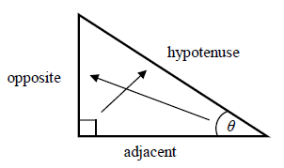Key points

* In a right-angled triangle:
* the side opposite the right angle is called the hypotenuse
* the side opposite the angle *θ* is called the opposite
* the side next to the angle *θ* is called the adjacent.
* In a right-angled triangle:
  + the ratio of the opposite side to the hypotenuse is the sine of angle *θ*, 
  + the ratio of the adjacent side to the hypotenuse is the cosine of angle *θ*, 
  + the ratio of the opposite side to the adjacent side is the tangent of angle *θ*, 
* If the lengths of two sides of a right-angled triangle are given, you can find a missing angle using the inverse trigonometric functions: sin−1, cos−1, tan−1.
* The sine, cosine and tangent of some angles may be written exactly.

|  |  |  |  |  |  |
| --- | --- | --- | --- | --- | --- |
|  | **0** | **30°** | **45°** | **60°** | **90°** |
| **sin** | 0 |  |  |  | 1 |
| **cos** | 1 |  |  |  | 0 |
| **tan** | 0 |  | 1 |  |  |

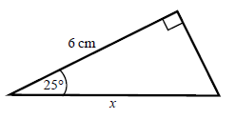Examples

**Example 1** Calculate the length of side *x*.  
 Give your answer correct to 3 significant figures.

|  |  |
| --- | --- |
| *x* = 6.620 267 5...  *x* = 6.62 cm | **1** Always start by labelling the sides.  **2** You are given the adjacent and the hypotenuse so use the cosine ratio.  **3** Substitute the sides and angle into the cosine ratio.  **4** Rearrange to make *x* the subject.  **5** Use your calculator to work out  6 ÷ cos 25°.  **6** Round your answer to 3 significant figures and write the units in your answer. |

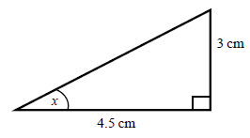

**Example 2** Calculate the size of angle *x*.  
 Give your answer correct to 3 significant figures.

|  |  |
| --- | --- |
| *x* = tan–1  *x* = 33.690 067 5...  *x* = 33.7° | **1** Always start by labelling the sides.  **2** You are given the opposite and the adjacent so use the tangent ratio.  **3** Substitute the sides and angle into the tangent ratio.  **4** Use tan−1 to find the angle.  **5** Use your calculator to work out  tan–1(3 ÷ 4.5).  **6** Round your answer to 3 significant figures and write the units in your answer. |

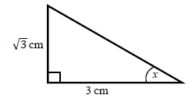**Example 3** Calculate the exact size of angle *x*.

|  |  |
| --- | --- |
| *x* = 30° | **1** Always start by labelling the sides.  **2** You are given the opposite and the adjacent so use the tangent ratio.  **3** Substitute the sides and angle into the tangent ratio.  **4** Use the table from the key points to find the angle. |

Practice

**1** Calculate the length of the unknown side in each triangle.  
 Give your answers correct to 3 significant figures.

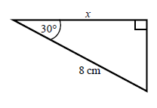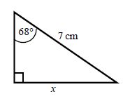 **a b**

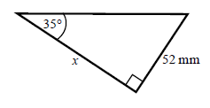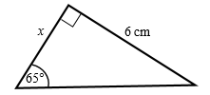 **c d**

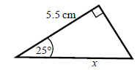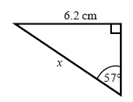 **e f**

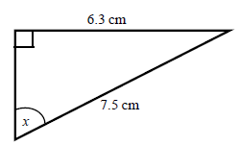**2** Calculate the size of angle *x* in each triangle.  
 Give your answers correct to 1 decimal place.

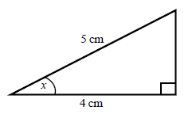 **a b**

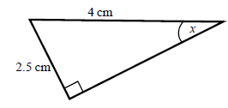

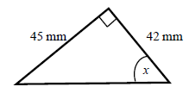 **c d**

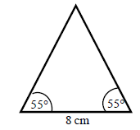**3** Work out the height of the isosceles triangle.  
 Give your answer correct to 3 significant figures.

**Hint:**

Split the triangle into two right-angled triangles.

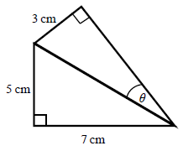**4** Calculate the size of angle *θ*.  
 Give your answer correct to 1 decimal place.

**Hint:**

First work out the length of the common side to both triangles, leaving your answer in surd form.

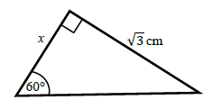**5** Find the exact value of *x* in each triangle.

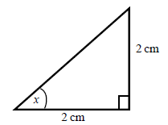 **a b**

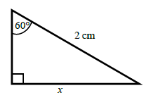

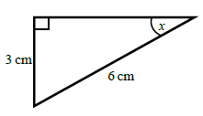 **c d**